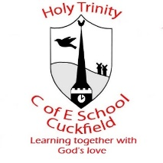
Instrumental Lessons 2026-2027

Piano, Keyboard, Voice and Flute | Piano, Voice and Flute | Drums | Guitar
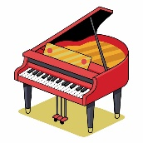  Clare Harms | 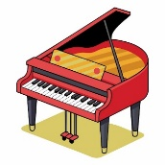  Rhiannon Harman | 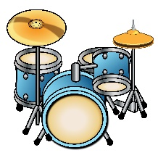  Pascal Headley | 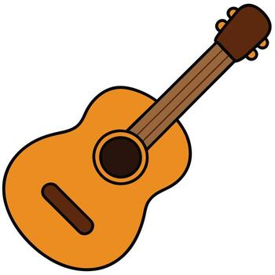  Fergus Patton
clareharmsart@gmail.com  07967 038758 | rhiannon@discoverandbe.com  Tel: 07472 521161 | Pascal Headley  07482103253  https://sites.google.com/view/westsussexdrums | ferguspatonguitarschool@gmail.com  07761 480100
Tuesday AM  Wednesday AM  Thursday AM | Monday all day  Tuesday PM | Wednesday PM  Friday PM | Thursday PM

 | AM  09:30-12:30 pm | PM  12:30-3:00 pm
Monday | 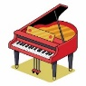  Rhiannon Harman
Tuesday | Clare Harms | Rhiannon Harman
Wednesday | Clare Harms |   Pascal Headley
Thursday | Clare Harms |   Fergus Patton
Friday | Rocksteady TBC | Pascal Headley

