
Holy Trinity CE (A) Primary





 1 



The following Progression in Calculation policy has been written to meet the requirements of the National Curriculum 2014 for the teaching and learning of Mathematics.

It is designed to give a consistent and smooth progression of learning in calculations from EYFS through to Year 6.

The Progression in Calculation policy is organised according to Year group expectations as set out in the National Curriculum. Your child will progress through the methods of calculation according to their ability within the four operations of addition, subtraction, multiplication and division.

The methods shown are only written ways of calculating. Children will also be calculating using mental strategies too.

During their time at Holy Trinity, children learn how to use models and images, such as empty number lines, to support their mental and informal written methods of calculation. As children’s mental methods are strengthened and refined, so too are their informal written methods. These methods become more efficient and succinct and lead to efficient written methods that can be used more generally. By the end of Year 6 children are equipped with mental and written methods that they understand and can use correctly.

When faced with a calculation, children are able to decide which method is most appropriate and have strategies to check its accuracy. They will do this by asking themselves:
- Can I do this in my head?
- Can I do this in my head using drawing or jottings?
- Do I need to use a pencil and paper procedure?

The overall aim is that when children leave in
Year 6 they:
- have a secure knowledge of number facts and a good understanding of the four operations;
- are able to use this knowledge and understanding to carry out calculations mentally and to apply general strategies when using one-digit and two-digit numbers and particular strategies to special cases involving bigger numbers;
- make use of diagrams and informal notes to help record steps and part answers when using mental methods that generate more information than can be kept in their heads;
- have an efficient and reliable written method of calculation for each operation that children can apply with confidence when undertaking calculations that they cannot carry out mentally;

In order to become confident, efficient and
accurate mathematicians, children will be encouraged to:
- approximate their answers before calculating.
- check their answers after calculation using an appropriate strategy.
- consider if a mental calculation would be appropriate before using written methods.





There are three people on the
bus. One more gets on. How many are there now?
☺☺☺☺☺ ☺ 5 + 1 = 6
EYFS: Find one more than a number from 1 to 20

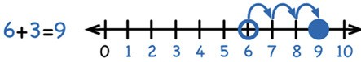

Use numbered number lines to add, by counting on in ones. Encourage children to start with the larger number and count on.
Year 1: Add with numbers up to 20

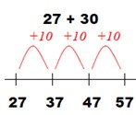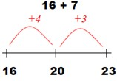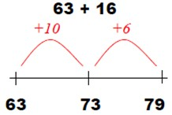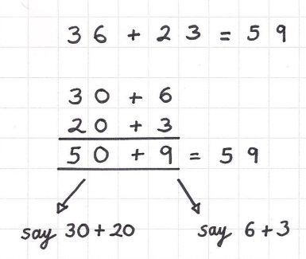
Year 2: Add with 2-digit numbers

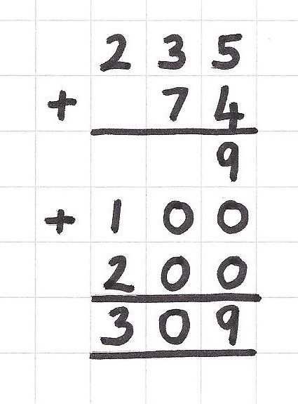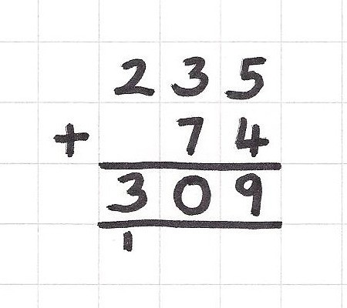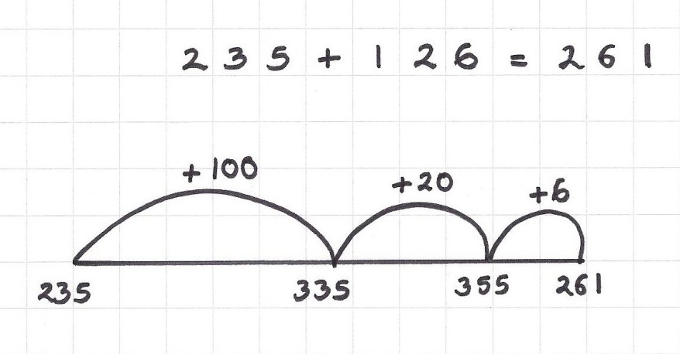
Year 3: Add numbers with up to 3 digits

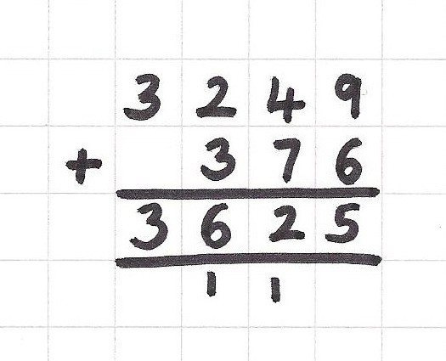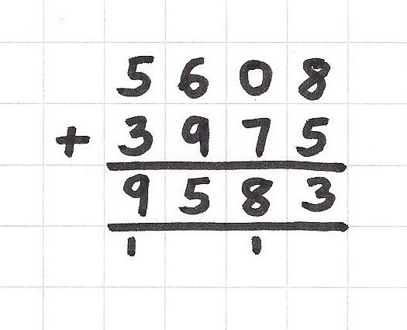
Year 4: Add numbers with up to 4 digits


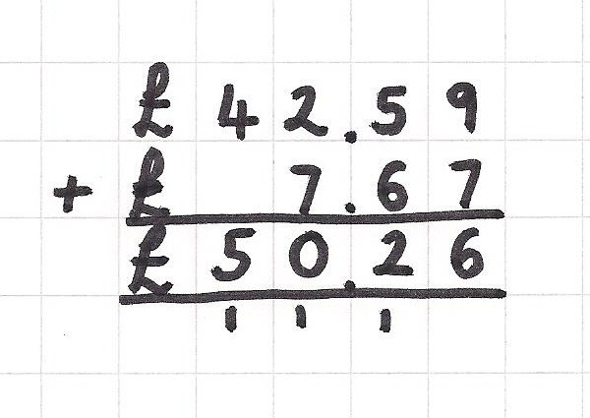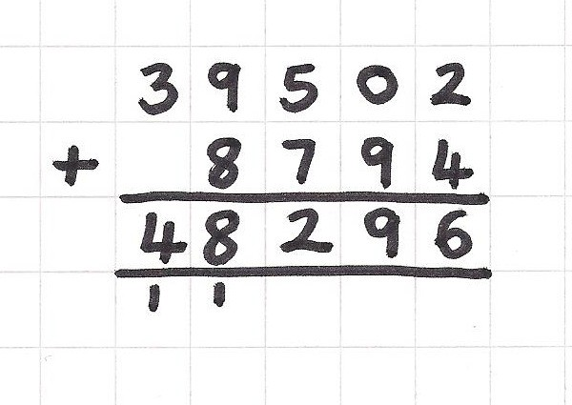
Year 5: Add numbers with more than 4 digits

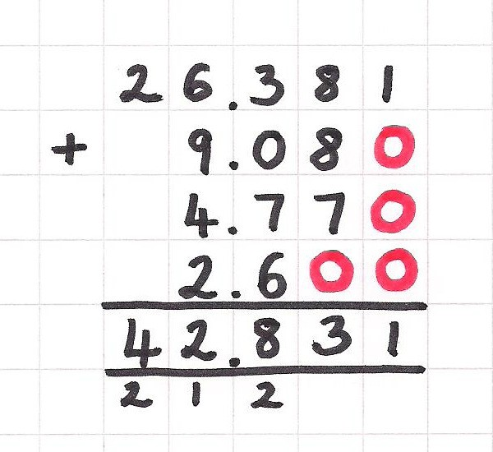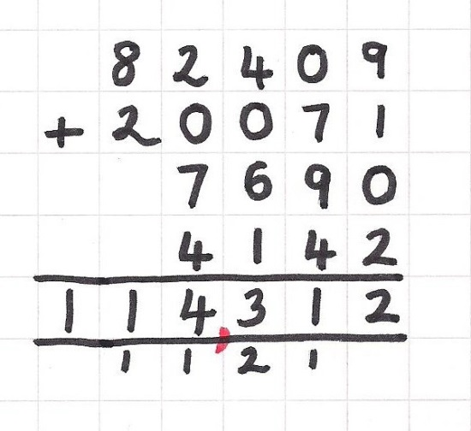
Year 6: Add several numbers of increasing complexity


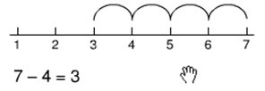
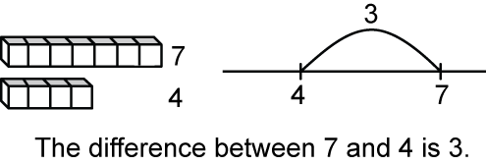
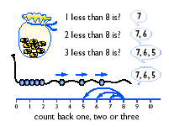
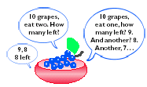
Count back in ones on a numbered number
line to take away, with numbers up to 20
= Seven is ‘3 more than’ four
Year 1: Subtract from numbers up to 20
EYFS: Find one less than a number from 1 to 20

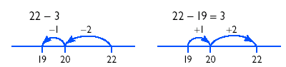
Counting back
Counting on
Year 2: Subtract with 2-digit numbers

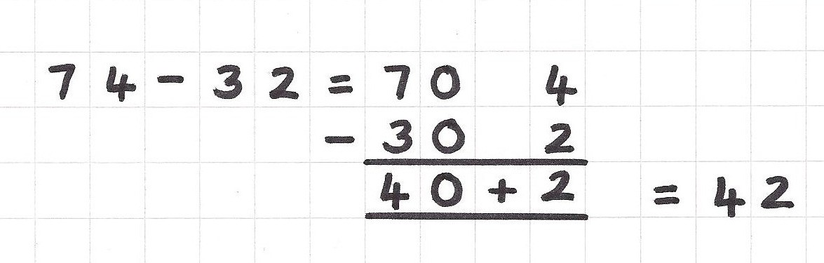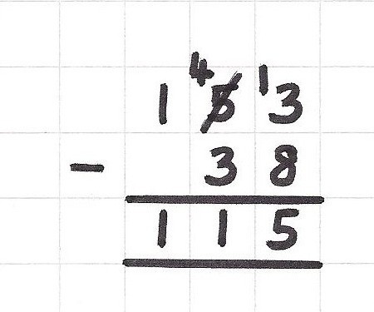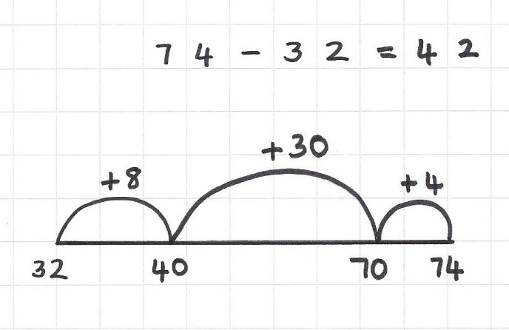
Counting on
Year 3: Subtract with 2 and 3-digit numbers

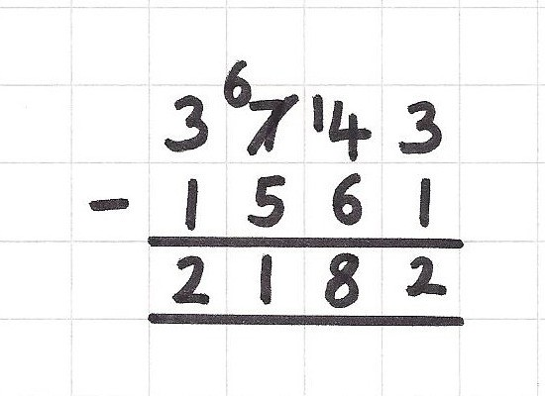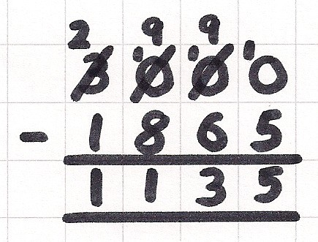
Year 4: Subtract with up to 4-digit numbers


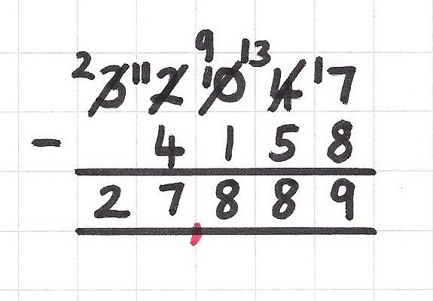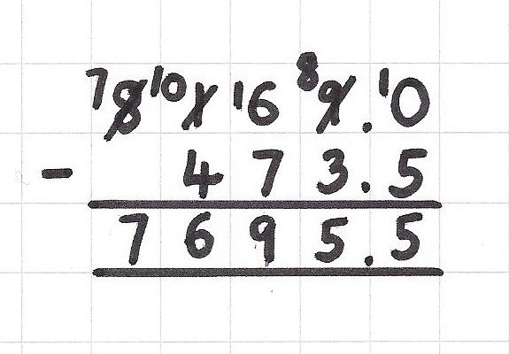
Year 5: Subtract with at least 4-digit numbers

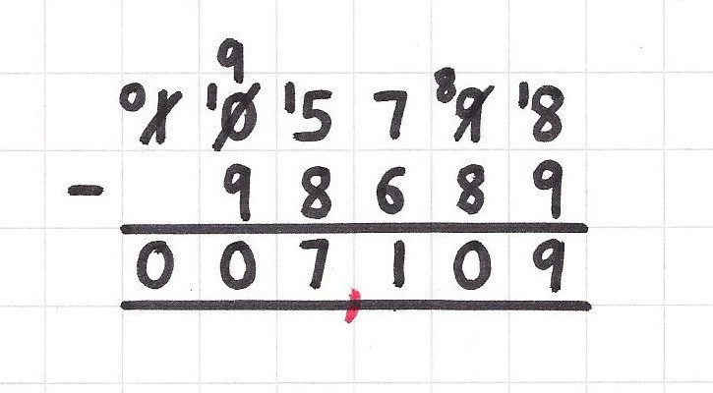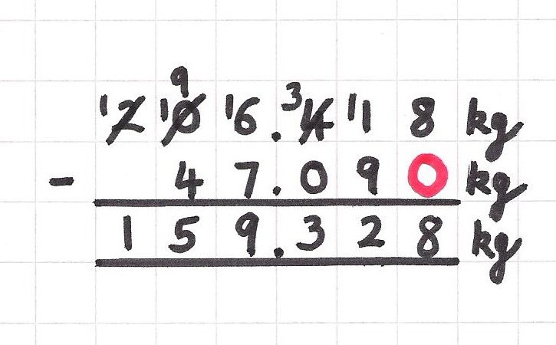
Year 6: Subtract with increasing large and more complex numbers and decimal values



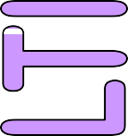


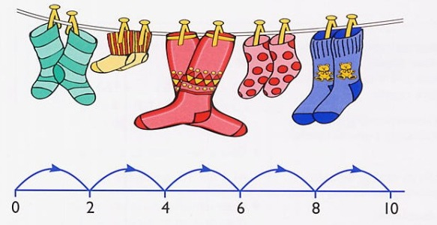
EYFS: Solve practical problems that involve doubling

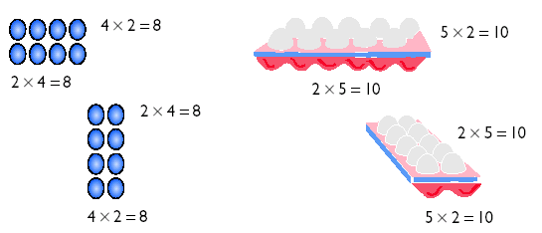
3 + 3 + 3 + 3 + 3 = 15
Year 1: Multiply with concrete objects, arrays and pictorial representations

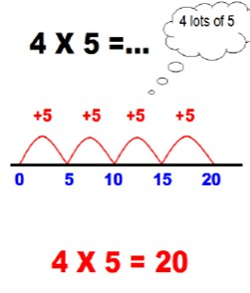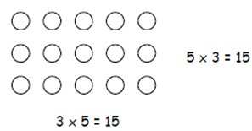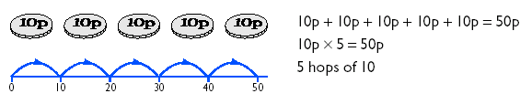
Year 2: Multiply using arrays and repeated addition (using at least 2s, 5s and 10s)


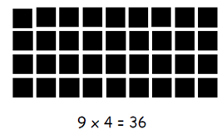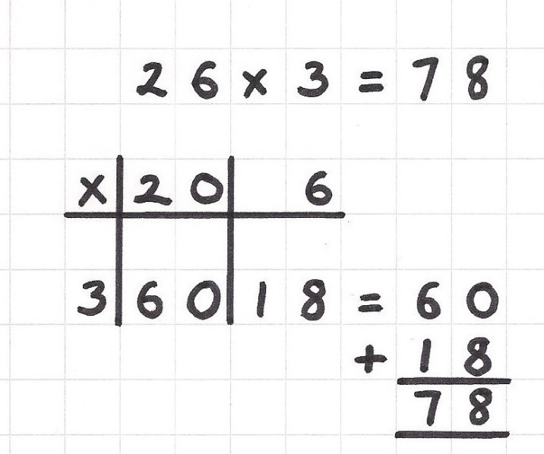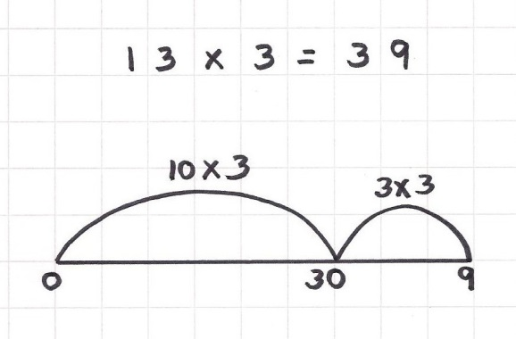
Grid multiplication
Year 3: Multiply 2-digit numbers by a 1-digit number

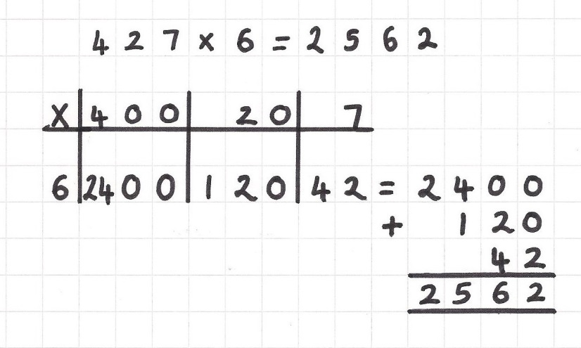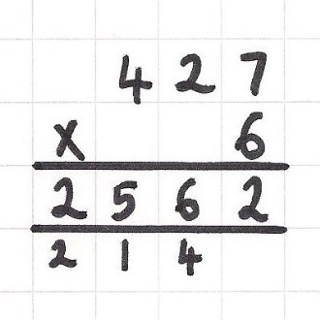
Grid multiplication
Short multiplication
Year 4: Multiply 2 and 3-digit numbers by a 1-digit number



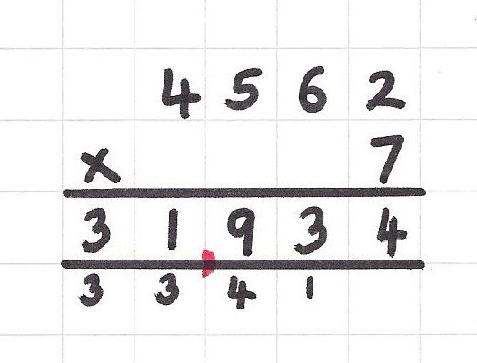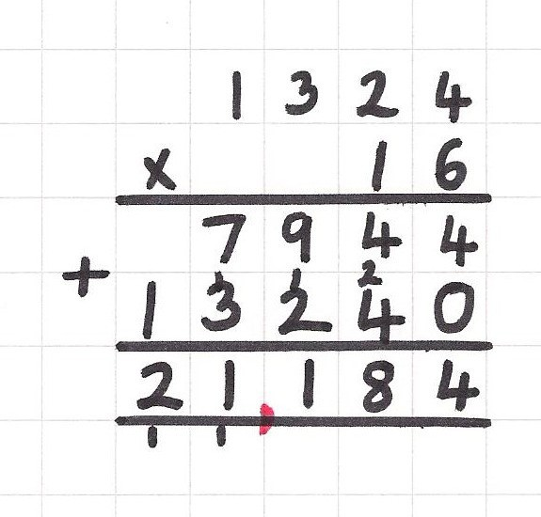
Short multiplication
Long multiplication
Year 5: Multiply up to 4-digit numbers by 1 or 2 digit numbers

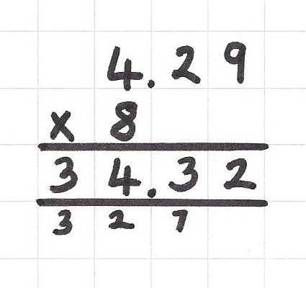
Short multiplication
Long multiplication
Year 6: Multiply up to 4-digit numbers by 1 or 2 digit numbers (see Year 5) and multiply decimals with 2 decimal places by a 1-digit number.






6 cakes are shared equally
between 2 children. How many cakes do they have each? SHARING
There are 6 cakes, how
many children can have 2 each? GROUPING
EYFS: Group, share and halve a number of objects
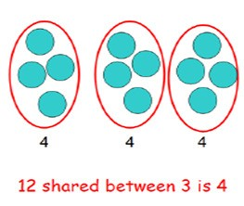
Grouping:
Sharing:
Year 1: Group and share small quantities

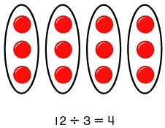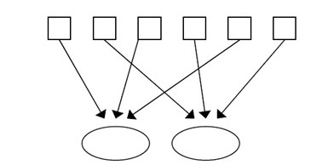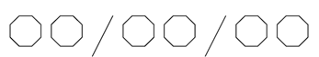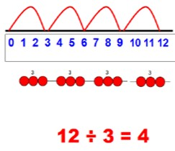
6 sweets are shared between 2 people. How many do they
each get?
There are 6 sweets, how many
people can have 2 sweets each?
Year 2: Group and share, using the ÷ and = sign
Sharing
Grouping



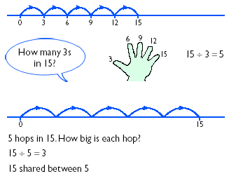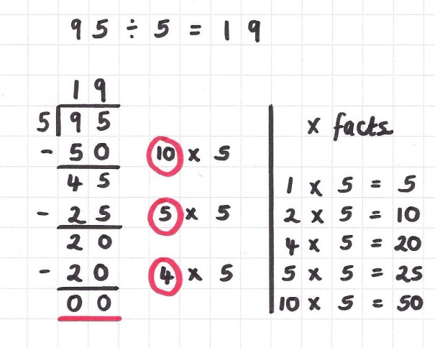
Long division
(Chunking method)
Year 3: Divide 2-digit numbers by a 1-digit number (where there is no remainder in the final answer)

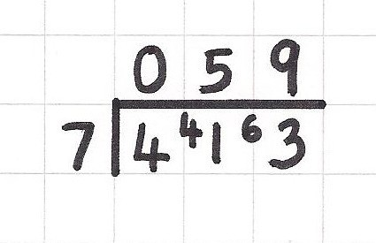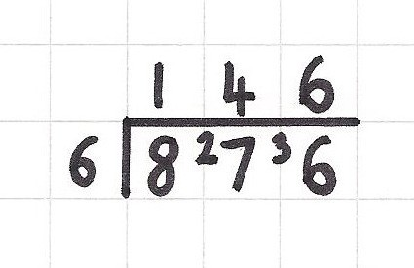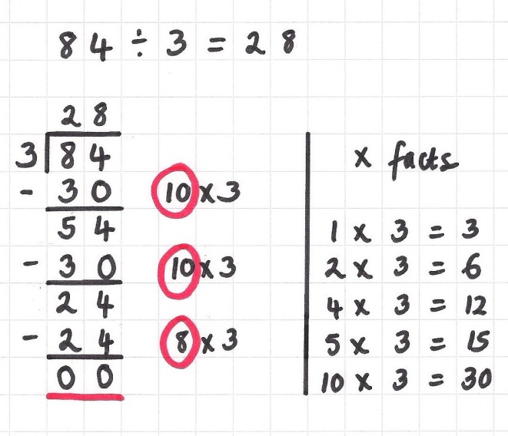
Long division
(Chunking method)
Short division
Year 4: Divide up to 3-digit numbers by a 1-digit number (without remainders initially)

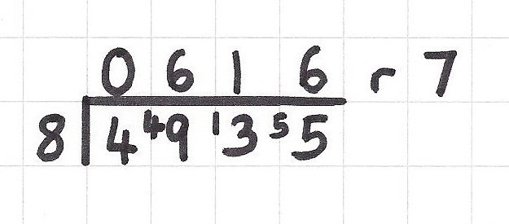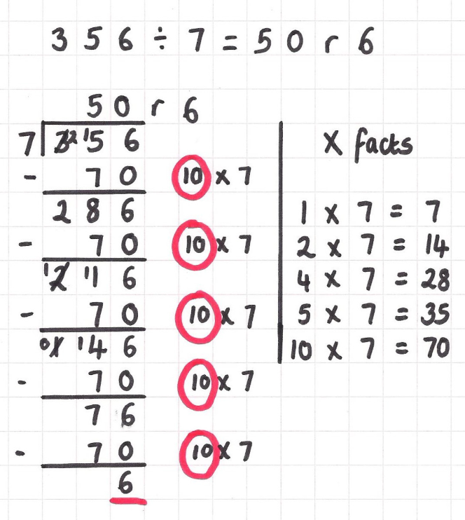
Short division
Long division
(Chunking method)
Year 5: Divide up to 4 digits by a 1-digit number, including those with remainders.

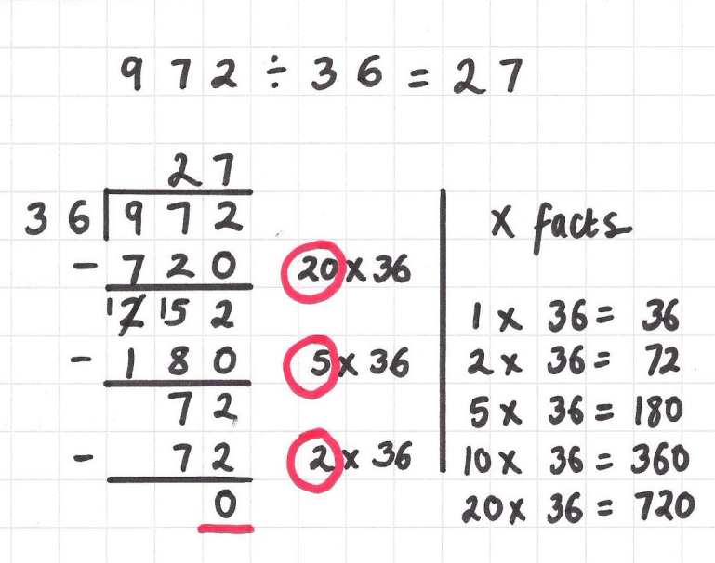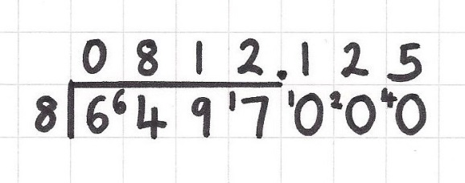
Short division
Long division
(Chunking method)
Year 6: Divide at least 4 digits by both 1-digit and 2-digit numbers (including decimal numbers and quantities)

