Dear Parents/Carers,

As we look forward to the academic year 2026-2027, we are delighted to share with you the Extra-Curricular Clubs and Instrumental Music Lessons Timetables. The attached timetables have more information of which clubs are running this year. If your child is interested in joining one of the clubs then please use the details provided to contact the club providers directly to register your child’s interest. Most club providers have a limited number of spaces and therefore the registration of the places is done on a first come first served basis. If when you contact the club provider, the club is full; your child will be put on a waiting list. Please also note that some clubs do not always open straight away – please check with them directly rather than the school office.
For the academic year 2026-2027 we will be changing the way clubs are booked. Unlike this year, where children were signed up for the whole year in advance, we are returning to our original system of opening registration at the start of each new term.
Therefore, the booking registers will open on the following dates and a reminder will be sent to you via parent pay to contact the club providers to book your child a space:
- Monday 6th July 2026 (for the Autumn Term)
- Monday 30th November 2026 (for the Spring Term)
- Monday 1st March 2027 (for the Summer Term)
There may however be some exceptions to the dates with some club providers so please refer to the individual club providers for further information. Please can we remind you that if for some reason your child will not be attending the club that you let the External Provider know as well as the school office using the following details (office@htprimary.co.uk) or by calling on 01444 454295.

Please see the table showing the exact dates for the extra-curricular clubs and music lessons.

 | Music Providers | Club Providers
Autumn Term | Monday 7th September 2026 –  Friday 11th December 2026  (13 weeks) | Monday 14th September 2026 –  Friday 11th December 2026  (12 weeks)
Half Term
Monday 26th October – Friday 30th October 2026
Spring Term | Monday 4th January 2027 –  Friday 19th March 2027  (10 weeks) | Monday 11th January 2027-  Friday 19th March 2027  (9 weeks)
Half Term
Monday 15th February – Friday 19th February 2027
Summer Term | Monday 12th April 2027 –  Friday 17th July 2027  (13 weeks) | Monday 19th April 2027 –  Friday 17th July  (12 weeks)
Half Term
Monday 31st May – Friday 4th June 2027
Bank Holidays/National Holidays with School Closed | 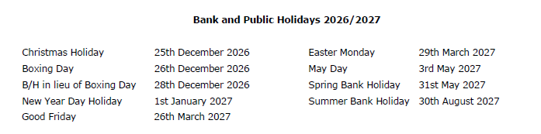
INSET DAYS | Tues 1st September  Mon 2nd Nov (HET)  Thurs 25th March (HET)  Weds 9th June (Reports)  Mon 5th July
We would also like to take this opportunity to remind parents, carers and children that signing up for a club is a commitment and would like to inform you of a new policy regarding club sign ups. If your son/daughter wishes to attend an extra-curricular activity they must make every effort to attend each week. A lot of people voluntarily and willingly give up their time to run these sessions and it is most disheartening to see numbers dwindle as the term goes on. From now on, if a child is absent for more than three consecutive sessions, they will be automatically removed from the club, and the next child on the waiting list will be offered a place.
Cancellation of school run clubs will be notified by ParentPay and/or a phone call from the office and the External Club Providers should contact you directly.
Collection at the End of the Club:
Due to safeguarding and our own wrap around care now being onsite until 6pm we have now asked for all club providers to walk their children to the front of the school office to be meet parents at the end of the club or if the children have permission to walk home then they will be dismissed from the front office. Therefore, collection after clubs is via the main entrance gate and from the front office.

If you have any questions, please do not hesitate to contact the school office.

Warm regards,

The School Office

