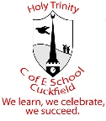
Holy Trinity Art & Design Whole School Curriculum
National Curriculum:
Purpose of Study
Art, craft and design embody some of the highest forms of human creativity. A high-quality art and design education should engage, inspire and challenge pupils, equipping them with the knowledge and skills to experiment, invent and create their own works of art, craft and design. As pupils progress, they should be able to think critically and develop a more rigorous understanding of art and design. They should also know how art and design both reflect and shape our history, and contribute to the culture, creativity and wealth of our nation.
Aims
The national curriculum for art and design aims to ensure that all pupils:
● produce creative work, exploring their ideas and recording their experiences
● become proficient in drawing, painting, sculpture and other art, craft and design techniques
● evaluate and analyse creative works using the language of art, craft and design
● know about great artists, craft makers and designers, and understand the historical and cultural development of their art forms
Subject Content
EYFS | Key Stage 1 | Key Stage 2
Expressive Arts and Design (Exploring and Using Media and Materials)  Children safely use and explore a variety of materials, tools and techniques, experimenting with colour, design, texture, form and function.  Expressive Arts and Design (Being Imaginative)  Children use what they have learnt about media and materials in original ways, thinking about uses and purposes. They represent their own ideas, thoughts and feelings through design and technology, art, music, dance, role play and stories. | Pupils should be taught:  - To use a range of materials creatively to design and make products  - To use drawing, painting and sculpture to develop and share their ideas, experiences and imagination  - To develop a wide range of art and design techniques in using colour, pattern, texture, line, shape, form, and space  - About the work of a range of artists, craft makers and designers, describing the differences and similarities between different practices and disciplines, and making links to their own work. | Pupils should be taught to develop their techniques, including their control and their use of materials, with creativity, experimentation, and an increasing awareness of different kinds of art, craft and design.  Pupils should be taught:  - To create sketch books to record their observations and use them to review and revisit ideas  - To improve their mastery of art and design techniques, including drawing, painting and sculpture with a range of materials (for example, pencil, charcoal, paint, clay)  - About great artists, architects and designers in history

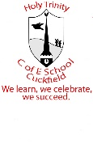
Art & Design at Holy Trinity
Intent: Our Vision
At Holy Trinity, children are given opportunities to express themselves creatively through the Art and Design curriculum, taking inspiration from the natural world wherever possible. We want our children to love art, craft and design and have no limits to their imaginations. Our high-quality Art curriculum is designed to engage, inspire, and challenge pupils, whilst equipping them with the knowledge and skills to be able to experiment, invent and create their own works of art. As pupils progress, they should be able to think critically and develop a more rigorous understanding of art and design. They should also know how art and design reflects and shapes our history and contribution to society.
We want the children to learn from a range of artists and cultures to respect diversity through the medium of art. To that end, we have carefully selected a wide range of unique and diverse artists, craft makers and designers for children to study.

Implementation: How we plan and teach Art and Design

Our curriculum is shaped by our school vision, which aims to enable all children to flourish and achieve their full potential in a supportive learning environment underpinned by a Christian ethos.
We use the National Curriculum to plan an engaging and exciting art curriculum. This ensures that the children are progressing and building on knowledge and procedural knowledge each year. Artist research is key for demonstrating examples of art techniques to the children, enabling them to make links to their own work. Art is planned with cross curricula links, ensuring that it is meaningful for the children. Lessons are carefully planned to meet the needs of all children, and adapted learning ensures that opportunities for support and challenge build on their individual artistic skills and knowledge.

Impact: How we evaluate our learning in Art and Design
Our Art curriculum is based on reflection and self-assessment to ensure that children are evaluating their own work, making meaningful suggestions for how they can improve. Art is subjective, and therefore each child is encouraged to evaluate their work based on their own artistic preferences. Teachers assess knowledge and procedural knowledge using the curriculum objectives.

Holy Trinity Art & Design
Progression of Procedural Knowledge
Drawing
EYFS | Year 1 | Year 2 | Year 3 | Year 4 | Year 5 | Year 6
Use a variety of drawing tools.  Draw closed shapes with continuous lines.  Use drawings to tell a story and represent ideas/feelings.  Investigate different lines – thick, thin, wavy, straight. To illustrate this, explore different textures and experiment with different mark makings.  Draw shapes that represent real and imagined objects and events.  Use drawing to represent ideas like movement or loud noises.  Add some detail to drawing for effect – eg shapes/lines for features on a face. | Experiment with mark making using a range of media.  Use a range of media to produce lines.  Observe and draw shapes from observation.  .  Make large and small scale observational drawings.  . | Experiment with a range of media to create line and tone (light and dark).  Understand how marks are being created and investigate how to create different lines and tones (how to make a darker mark, lighter mark, wider mark, narrow mark).  Begin to represent objects with a view to their relative / comparative size (drawing to scale, a person is smaller than a house). | Experiment with different media for effect.  Experiment with different grades of pencil.  Create tone using techniques such as: blending from dark to light using pencil/patterns to represent texture of objects/ tone to represent shape.  Begin to blend colours using chalks, pencils, oil pastels.  Create texture using a range of lines and tones. | Demonstrate perspective using line or tone.  Experiment with showing line, tone and texture with different grades of pencil.  Use shading to show light and shadow effects.  Use different materials to draw.  Draw objects with correct proportions.  Draw objects from different viewpoints.  Draw on different scales (taking something small and enlarging it and taking something large and shrinking it. | Develop simple perspective in their work using a single focal point and horizon.  Experiment with showing line, tone and texture with different grades of pencil.  Use shading to show light and shadow effects.  Use different materials to draw for effect.  Use different techniques for different purposes e.g. shadows, reflection, hatching and cross-hatching.  Develop a key element of their work: line, tone, pattern, texture. | Use a variety of techniques to add effects, e.g. shadows, reflection, hatching and cross-hatching.  Depict movement and perspective in drawings.  Use a variety of tools and select the most appropriate.  Use drawing techniques to work from a variety of sources including observation, photographs and digital images.

Painting
EYFS | Year 1 | Year 2 | Year 3 | Year 4 | Year 5 | Year 6
Use a variety of painting tools.  Paint on a range of surfaces.  Names of colours.  Choose a colour for a purpose.  Experiment with colours and colour mixing.  Paint real and imagined objects and events.  Use paints and brushes to make a variety of marks – dots, dabs, zig zags.  Use painting to tell a story and represent ideas/feelings. | Be able to hold a paintbrush correctly and use the tip to paint with.  Experiment with mark making with different brush sizes and types.  Name the primary colours and identify them on a colour wheel and in other forms.  Mix primary colours to make secondary colours, predicting resulting colours.  Find collections of colours.  Explore lightening and darkening paint without the use of black or white.  Experiment with different types of paint. | Experiment with painting with different brush sizes and types.  Use a brush to produce marks appropriate to work e.g. small brush for small marks.  Mix secondary colours from primary colours, plus begin to make tints and shades by adding colour to white and dark colours to lighter colours  Experiment with . thicknesses of paint (watercolour/ready mix).  Be able to describe the difference between textures of different paints and the effect they have.  Create washes using watercolour paint.  Create movement using a range of techniques (such as: repetition of shapes, swirling arcs, circles, swirls). | Experiment with different effects and textures.  Use light and dark when painting, mixing shades and tints for particular effects.  Explore complementary colours – colours opposite each other on the colour wheel.  Work on different scales, selecting suitable brush size and type.  Use varied brush techniques to create shapes, textures, patterns and lines. | Work with increasing detail, using appropriate brushes.  Experiment with applying colour in different ways e.g. dotting, stippling, scratching, and splashing.  Colour mix to explore harmonies using the correct language, e.g. tint, shade, primary and secondary.  Use light and dark within painting and show understanding of complementary colours.  Use varied brush techniques to create shapes, textures, patterns and lines.  Create different textures and effects with paint.  Compare different surfaces to paint on and explain the effect on each.  Work with a range of paints. | Create a colour palette, demonstrating mixing techniques.  Colour mix to explore harmonies, using the correct language.  Use colour to create atmosphere and light effects.  Explore complementary opposites and contrasting colours.  Use a range of paint for particular purposes.  Create different textures and effects with paint.  Develop a painting from a drawing.  Create compositions and select from 2 or 3 ideas. | Choose the type of paint and tools to use for a particular purpose.  Control and experiment with tones, shades and mood, building on previous knowledge.  Create compositions and select from 2 or 3 ideas.  Mix colour, shades, tints and tones to achieve an intended effect.  Create different textures and effects with paint.  Develop an awareness of scale and proportion in their own work.

Sculpture
EYFS | Year 1 | Year 2 | Year 3 | Year 4 | Year 5 | Year 6
Build and stack objects in play.  Use a variety of tools to shape, assemble and join materials.  Build and join 3D structures using a range of materials for a specific purpose.  Use blocks/construction toys to build small worlds.  Adapt constructions to achieve desired outcome. | Explore sculpture with a range of materials.  Experiment with constructing and joining recycled, natural and manmade materials.  Select objects to join together using tape and glue.  Select items to decorate and fix.  Sort and arrange materials. | Plan, design and make models from observation or imagination.  Be able to manipulate modelling materials, including clay  Understand what happens to clay when you add water.  Experiment with rolling clay and pressing objects into it.  Develop understanding of different media and joining.  Be able to form specific 3D shapes from clay.  Be able to use clay to create a freestanding form  Use a variety of techniques – rolling, cutting, pinching  Join clay, constructing a simple tile base and then layering/joining shapes onto it to create 3D form | Plan, design and make models from observation or imagination  Cut, make and combine shapes to create recognisable forms  Add materials to a sculpture to create detail | Plan, design and make models from observation or imagination.  .  Make 3D models by constructing materials.  Add materials to sculpture to create detail.  Cut, join and shape wire.  Twist wire to create shape.  Join wires using twists. | Manipulate materials to make a new 3D form.  Use covering materials such as Modroc or modelling clay to create 3D models.  Practise cutting and joining techniques.  Use smoothing techniques to create a desired finish. | Manipulate materials to make a new 3D form based on a brief.  Add final finishes to models using paint/glazing techniques.  Use smoothing techniques to create a desired finish before painting.  Experiment with different forming techniques.  Experiment with different tools.  Create patterns to represent texture.  Apply patterns to a 3D form.

EYFS
Autumn – Expressive Art and Design  Explores different materials freely, in order to develop his/her ideas about how to use them and what to make  Is developing his/her own ideas and is then able to decide which materials to use to express them  Can join different materials and explore different textures  Can create closed shapes with continuous lines, and is beginning to use these shapes to represent objects  Is drawing with increasing complexity and detail, such as representing a face with a circle and including details  Uses drawing to represent ideas like movement or loud noises  Explores colour and colour-mixing | Spring – Expressive Art and Design  Explores, uses and refines a variety of artistic effects to express his/her ideas and feelings  Is able to return to and build on his/her previous learning, refining ideas and developing his/her ability to represent them  Creates collaboratively sharing ideas, resources and skills | Summer – Expressive Art and Design  Safely use and explore a variety of materials, tools and techniques, experimenting with colour, design, texture, form and function;  Share their creations, explaining the process they have used;  Make use of props and materials when role playing characters in narratives and stories.
Cross Curricula Link: We’re Going on a Bear Hunt, Biscuit Bear, Autumn, Naughty Bus, Biscuit Bear, Oh No George, People Who Help Us, Dinosaurs, Jolly Postman.  Children should be taught to:  Key Vocabulary: Mark making, Drawing, Tools, Pencil, Pen, Oil pastel, Chalk, Charcoal, Straight, Continuous, Dots, Circle, Colours, Shape, Paints, Paint Brushes, Paint Palette, Build, Stack, Join Materials  Artists: Book illustrations  Suggested Outcomes:  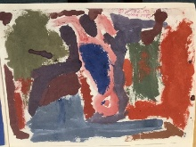  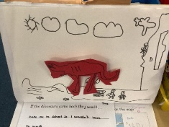  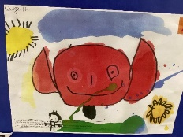 | Cross Curricula Link: How to find a fruit bat, Blue Penguin, Anna Hibiscus, Australia, Look inside Space, Spring/Easter, The train ride, No Dinner  Children should be taught to:  Drawing  - Use drawings to tell a story and represent ideas/feelings.  - Use drawing to represent ideas like movement or loud noises.  - Add some detail to drawing for effect – eg shapes/lines for features on a face.  Painting  - Choose a colour for a purpose.  - Paint real and imagined objects and events.  - Use paints and brushes to make a variety of marks – dots, dabs, zig zags.  Sculpture  - Build and join 3D structures using a range of materials for a specific purpose.  Key Vocabulary: Mark making, Drawing, Tools, Pencil, Pen, Oil pastel, Chalk, Charcoal, Straight, Continuous, Dots, Circle, Colours, Shape, Paints, Paint Brushes, Paint Palette, Build, Stack, Join Materials  Artists: Various indigenous artists  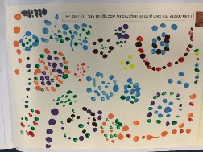  Suggested Outcomes:  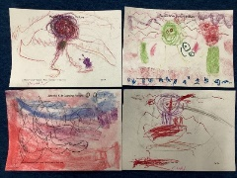  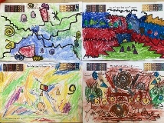 | Cross Curricula Link: Kings and Queens, Errol’s garden, The Gigantic Turnip, The Very Hungry Caterpillar  Children should be taught to:  Drawing  - Investigate different lines – thick, thin, wavy, straight. To illustrate this, explore different textures and experiment with different mark makings.  Painting  - Paint on a range of surfaces.  - Experiment with colours and colour mixing.  Sculpture  - Adapt constructions to achieve desired outcome.  Key Vocabulary: Mark making, Drawing, Tools, Pencil, Pen, Oil pastel, Chalk, Charcoal, Straight, Continuous, Dots, Circle, Colours, Shape, Surfaces, Textures, Paints, Paint Brushes, Paint Palette, Build, Stack, Join Materials  Artists: Eric Carle  Suggested Outcomes:  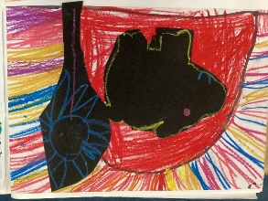  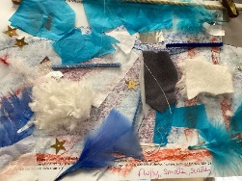  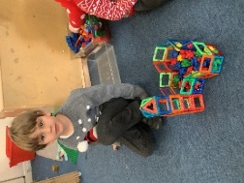
  Drawing
  - Use a variety of drawing tools.
  - Draw closed shapes with continuous lines.
  - Draw shapes that represent real and imagined objects and events.
  Painting
  - Use a variety of painting tools.
  - Names of colours.
  - Use painting to tell a story and represent ideas/feelings.
  Sculpture
  - Build and stack objects in play.
  - Use a variety of tools to shape, assemble and join materials.
  - Use blocks/construction toys to build small worlds.
Year 1
Autumn – Drawing  KS1 Art and Design National Curriculum  To become proficient in drawing techniques.  To use drawing to develop and share their ideas, experiences and imagination. | Spring – Sculpture & Collage  KS1 Art and Design National Curriculum  To become proficient in sculpting techniques.  To use sculpture to develop and share their ideas, experiences and imagination. | Summer – Painting  KS1 Art and Design National Curriculum  To become proficient in painting techniques.  To use painting to develop and share their ideas, experiences and imagination.
Cross Curricula Link: Science – Seasons/Animals  Enrichment: Nature walk, Drusillas trip  Children should be taught to:  Key Vocabulary: Line, Vertical, Horizontal, Diagonal, Wavy, Straight, Shade, Form, Continuous, Mark making, Observe, Dots, Circle, Lightly, Firmly, Texture, Shadow, Charcoal, Pastel, Chalk  Artists: John Nash, John Constable, Tate online Seasons gallery  Suggested Outcome: Observational Drawings of objects in nature, sketches of animal skins  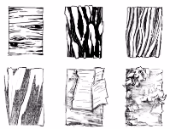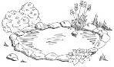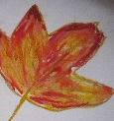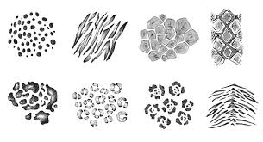 | Cross Curricula Link: PoR text The Robot and the Bluebird, Maths – shape  Children should be taught to:  Sculpture  - Explore sculpture with a range of materials  - Experiment with constructing and joining recycled, natural and manmade materials  - Select objects to join together using tape and glue  - Select items to decorate and fix  Collage  - Sort and arrange materials based on their properties  - Fold, crumble, tear and overlap papers and other materials  - Work on different scales  - In relation to artists/designers/craft makers – describe their work, express opinions, and use inspiration to create own work, drawing comparisons  Key Vocabulary: collage, features, cut, place, arrange, shape, 2D, 3D, sculpture, model, join, stable  Artists: Matisse, Michelle Reader, Robert Bradford,  Suggested Outcomes: Create a collage using 2D shapes, create a robot model using 3D recycled materials  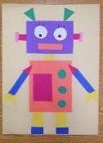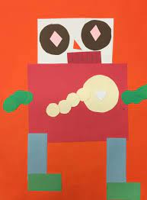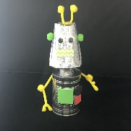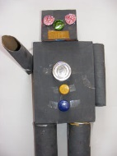 | Cross Curricula Link: PoR text Look Up  Enrichment: Space day  Children should be taught to:  - Be able to hold a paintbrush correctly and use the tip to paint with  - Experiment with mark making with different brush sizes and types  - Name the primary colours and identify them on a colour wheel and in other forms  - Mix primary colours to make secondary colours, predicting resulting colours  - Find collections of colours  - Explore lightening and darkening paint  - Experiment with different types of paint  - In relation to artists/designers/craft makers – describe their work, express opinions, and use inspiration to create own work, drawing comparisons  Key Vocabulary: Shade, Tint, Primary colour, Secondary colour, Pattern, Mix, Blend, Print, Shape, Kaleidoscope,  Texture, Light, Dark, Bright, Dull  Artists: Tarsila Do Amaral, Van Gogh  Suggested Outcomes: Night sky paintings  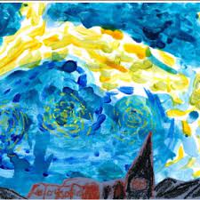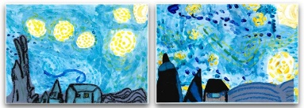
  - Experiment with mark making using a range of media
  - Use a range of media to produce lines
  - Observe and draw shapes from observation
  - Make large and small scale observational drawings
  - In relation to artists/designers/craft makers – describe their work, express opinions, and use inspiration to create own work, drawing comparisons
Year 2
Autumn – Painting & Collage  KS1 Art and Design National Curriculum  To become proficient in painting techniques.  To use painting to develop and share their ideas, experiences and imagination.  To become proficient in other art, craft and design techniques – collage.  To develop a wide range of art and design techniques in using texture, line, shape, form and space. | Spring – Drawing & Printing  KS1 Art and Design National Curriculum  To become proficient in drawing techniques.  To use drawing to develop and share their ideas, experiences and imagination.  To become proficient in other art, craft and design techniques – printing.  To develop a wide range of art and design techniques in using colour and texture. | Summer – Sculpture  KS1 Art and Design National Curriculum  To become proficient in sculpting techniques.  To use sculpture to develop and share their ideas, experiences and imagination.
Cross Curricula Link: PoR - Emperor’s Egg, Science – Habitats  Enrichment: Wildlife Trust workshop on habitats  Children should be taught to:  Painting  - Experiment with mark making using a range of brushes  - Use a brush to produce marks appropriate to work e.g. small brush for small marks  - Mix secondary colours from primary colours plus: begin to make tints and shades by adding colour to white and dark colours to lighter colours  - Experiment with different thicknesses of paint (watercolour/ready mix)  - Be able to describe the difference between textures of different paints and the effect they have  - Create washes using watercolour paint  - Create movement using a range of techniques (such as: repetition of shapes, swirling arcs, circles, swirls)  Collage  - Use a combination of materials that have been cut, torn and glued  - Sort and arrange materials  - Add texture by mixing materials  - In relation to artists/designers/craft makers – describe their work, express opinions and use inspiration to create own work, drawing comparisons.  Key Vocabulary: primary colours, secondary colours, neutral colours, tints, shades, warm colours, cool colours, sweep, dab, bold brushstroke,.collage, squares, gaps, features, cut, place, arrange.  Artists: Alma Thomas  Suggested Outcomes: Alma Thomas inspired paintings, Antarctic scene collages  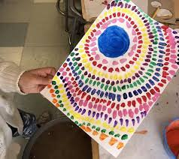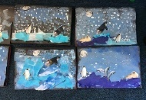 | Cross Curricula Link: PoR- Lonely Beast  Key Vocabulary: portrait, line drawing, detail, landscape, cityscape, silhouette, building, horizon, half turn, horizon, pastels, drawings, line, tone, bold, size, space.  Artists: Monet, Lowry  Suggested Outcomes: Cityscape drawings, block prints 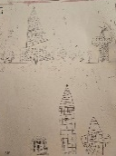 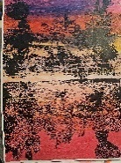 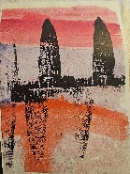 | Cross Curricula Link PoR – Hortense and her shadow, Science – Plants  Enrichment: Wakehurst trip  Children should be taught to:  - Plan, design and make models from observation or imagination  - Be able to manipulate modelling materials, including clay  - Understand what happens to clay when you add water  - Experiment with rolling clay and pressing objects into it  - Develop understanding of different media and joining  - Be able to form specific 3D shapes from clay  - Join clay, constructing a simple tile base and then layering/joining shapes onto it to create 3D form  - Create surface patterns and textures onto clay  - Use a variety of techniques – rolling, cutting, pinching  - In relation to artists/designers/craft makers – describe their work, express opinions and use inspiration to create own work, drawing comparisons  Key Vocabulary: sculpture, statue, model, work, work of art, 3D, land art, sculptor, carving, sculpture, installation, shapes, materials, pinching, rolling, cutting  Artists: Various artists and craft makers  Suggested Outcomes: Nature themed clay tiles  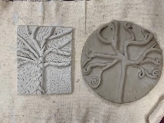  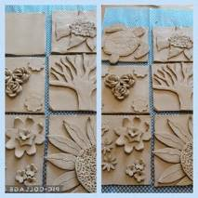  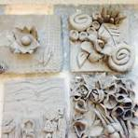
  Children should be taught to:
  Drawing
  - Experiment with a range of media to create line and tone (light and dark)
  - Understand how marks are being created and investigate how to create different lines and tones (how to make a darker mark, lighter mark, wider mark, narrow mark.)
  - Begin to represent objects with a view to their relative/ comparative size
  Printing
  - Copy an original print
  - Use a variety of materials and tools for printing
  - Apply a range of techniques
  - In relation to artists/designers/craft makers – describe their work, express opinions and use inspiration to create own work, drawing comparisons
Year 3
Autumn - Drawing & Printing  KS2 Art and Design National Curriculum  To become proficient in painting techniques.  To become proficient in sculpting techniques.  To improve their mastery of art and design techniques, including sculpting with a range of materials | Spring - Drawing  KS2 Art and Design National Curriculum  To improve their mastery of art and design techniques with a range of materials – collage.  To become proficient in drawing techniques. | Summer – Painting, Sculpture & Collage  KS2 Art and Design National Curriculum  To become proficient in drawing techniques.  To improve their mastery of art and design techniques, including drawing and printing, with a range of materials.
Cross Curricula Link: History – Stone Age  Children should be taught to:  Drawing  - Experiment with different media for effect  - Experiment with different grades of pencil  - Create tone using techniques such as: blending from dark to light using pencil/patterns to represent texture of objects/ tone to represent shape.  - Begin to blend colours using chalks, pencils, oil pastels  - Create texture using a range of lines and tones  - Reflect upon their work inspired by a notable artist/designer/craft maker and the development of their art skills  - Express an opinion on the work of notable artists and refer to techniques and effect  Printing  - Use more than one colour to layer in a print  - Replicate patterns from observations  - Make printing blocks  - Make repeated patterns with precision  - Use inspiration from notable artists to replicate a piece of work  - Reflect upon their work inspired by a notable artist/designer/craft maker and the development of their art skills  - Express an opinion on the work of notable artists and refer to techniques and effect  Key Vocabulary: relief, print, stencils, cave, stone  Artists: Lascaux, Magura, Cuevas De Las Manos  Suggested Outcomes: Cave paintings, prints  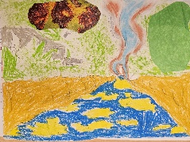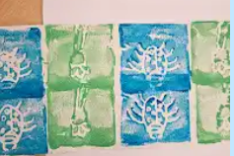 | Cross Curricula Link: PoR – Paper Bag Prince  Children should be taught to:  Drawing  - Experiment with different media for effect  - Experiment with different grades of pencil  - Create tone using techniques such as: blending from dark to light using pencil/patterns to represent texture of objects/ tone to represent shape.  - Begin to blend colours using chalks, pencils, oil pastels  - Create texture using a range of lines and tones  - Use inspiration from notable artists to replicate a piece of work  - Reflect upon their work inspired by a notable artist/designer/craft maker and the development of their art skills  - Express an opinion on the work of notable artists and refer to techniques and effect  Key Vocabulary: portrait, light, dark, tone, shadow, line, pattern, texture, form, shape, tone, outline  Artists: Andy Goldsworthyn Pablo Picasso  Suggested Outcomes: Self-portraits  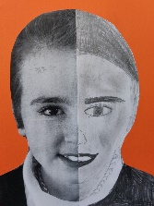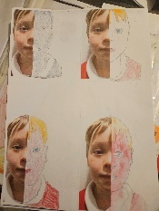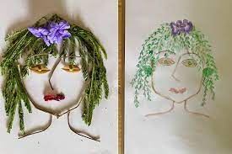 | Cross Curricula Link: History – Romans  Enrichment: Roman day, Fishbourne trip  Key Vocabulary: cutting, shapes, sticking, texture, rough, soft, smooth, hard, delicate, overlap, bumpy, uneven, form, pattern  .  Artists: Various Roman craft makers  Suggested Outcomes: Mosaics, paper/willow sculptures , book covers  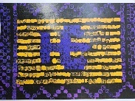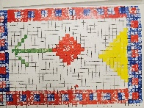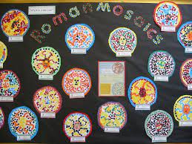
  Children should be taught to:
  Painting
  - Experiment with different effects and textures
  - Use light and dark when painting, mixing shades and tints for particular effects
  - Explore complementary colours – colours opposite each other on the colour wheel
  - Work on different scales, selecting suitable brush size and type
  - Use varied brush techniques to create shapes, textures, patterns and lines
  Collage
  - Select colours and materials to create effect, giving reasons for their choices
  - Refine work as they go to ensure precision
  - Learn and practise a variety of techniques, e.g. overlapping, tessellation, mosaic and montage
  Sculpture
  - Plan, design and make models from observation or imagination
  - cut, make and combine shapes to create recognisable forms

Year 4
Autumn – Sculpture & Drawing  KS2 Art and Design National Curriculum  To become proficient in sculpting techniques.  To improve their mastery of art and design techniques, including sculpting with a range of materials. |  | Spring – Drawing  KS2 Art and Design National Curriculum  To become proficient in drawing techniques.  To improve their mastery of art and design techniques, including drawing, with a range of materials. |  | Summer – Painting  KS2 Art and Design National Curriculum  To become proficient in painting techniques.  To improve their mastery of art and design techniques, including painting with a range of materials.
Cross Curricula Link: Science - Animals  Key Vocabulary: sculpt, stippling, contouring, ink washing, hatching, blending, sculpture, mod roc, architect  Artists: Anthony Gormley  Suggested Outcomes: Animal sketches and sculptures  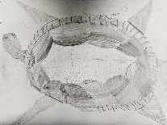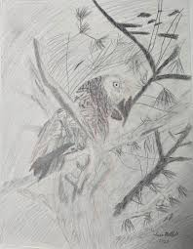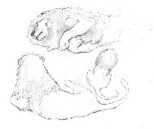 |  | Cross Curricula Link: PoR – Beowulf  Children should be taught to  - Demonstrate perspective using line or tone  - Experiment with showing line, tone and texture with different hardness of pencils  - Use shading to show light and shadow effects  - Use different materials to draw  - Draw objects with correct proportions  - Draw objects from different viewpoints  - Use inspiration from notable artists to replicate a piece of work  - Reflect upon their work inspired by a notable artist/designer/craft maker and the development of their art skills  - Express an opinion on the work of notable artists and refer to techniques and effect  Key Vocabulary: portrait, light, dark, tone, shadow, line, pattern, texture, form, shape, tone, outline.  Artists: Anne Stokes, Beowulf illustrators  Suggested Outcomes: Beowulf and dragon eye drawings  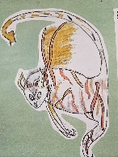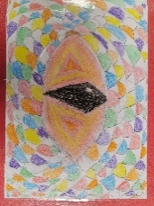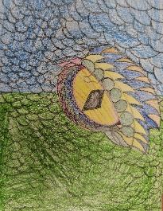 |  | Enrichment: Local artist workshop  Children should be taught to  - Work with increasing detail, using appropriate brushes  - Experiment with applying colour in different ways e.g. dotting, stippling, scratching, splashing  - Colour mix to explore harmonies using the correct language, e.g. tint, shade, primary and secondary  - Use light and dark within painting to show complementary colours  - Use varied brush techniques to create shapes, textures, patterns and lines  - Create different textures and effects with paint  - Compare different surfaces to paint on and explore the effect on each  - Work with a range of paints  - Use inspiration from notable artists to replicate a piece of work  - Reflect upon their work inspired by a notable artist/designer/craft maker and the development of their art skills  - Express an opinion on the work of notable artists and refer to techniques and effect  Key Vocabulary: colour, foreground, middle ground, background, abstract, perspective, emotion, warm, blend, mix, tint, shade, line, tone, fresco.  Artists: David Hockney, Hokusai, Hugo Pineda  Suggested Outcomes: Observational shell drawings and abstract seascapes  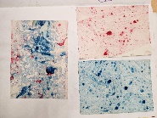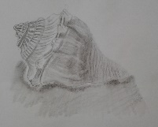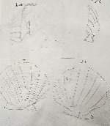
  Children should be taught to:
  Sculpture
  - Plan, design and make models from observation or imagination
  - Make 3D models by constructing materials
  - Add materials to sculpture to create detail
  - Cut, join and shape wire
  - Twist wire to create shape
  - Join wires using twists
  Drawing
  - Demonstrate perspective using line or tone
  - Experiment with showing line, tone and texture with different hardness of pencils
  - Use shading to show light and shadow effects
  - Use different materials to draw
  - Show an awareness of space when drawing
  - Draw objects with correct proportions
  - Draw objects from different viewpoints
  - Draw on different scales (taking something small and enlarging it and taking something large and shrinking it)
  - Use inspiration from notable artists to replicate a piece of work
  - Reflect upon their work inspired by a notable artist/designer/craft maker and the development of their art skills
  - Express an opinion on the work of notable artists and refer to techniques and effect
Year 5
Autumn – Painting  KS2 Art and Design National Curriculum  To become proficient in painting techniques.  To improve their mastery of art and design techniques, including painting with a range of materials. | Spring – Drawing & Sculpture  KS2 Art and Design National Curriculum  To become proficient in drawing techniques.  To improve their mastery of art and design techniques, including drawing, with a range of materials. To become proficient in sculpting techniques. |  | Summer –Collage, Drawing & Painting  KS2 Art and Design National Curriculum  To become proficient in painting techniques.  To improve their mastery of art and design techniques, including painting and collage with a range of materials.
Cross Curricula Link: Science – Earth and Space  Enrichment: Herstmonceux observatory  Children should be taught to  - Create a colour palette, demonstrating mixing techniques  - Colour mix to explore harmonies using the correct language  - Use a range of paint to create visually interesting pieces  - Explore complementary opposites and contrasting colours  - Create different textures and effects with paint  - Build on mark making by exploring different shapes  - Create compositions and select from 2 or 3 ideas  - Reflect upon their work inspired by a notable artist/designer/craft maker and the development of their skills  - Make observations about the work of notable artists/designers/craft makers  - Facts about the lives and work of notable artists/designers/craft makers  Key Vocabulary: blend, mix, line, tone, shape, abstract, absorb, colour, pop art, culture, portrait  Artists: Andy Warhol, Roy Lichtenstein  Suggested Outcomes: Galaxy scene, self-portrait in pop art style, book cover, rocket painting  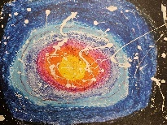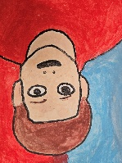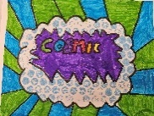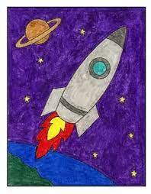 | Cross Curricula Link: Geography & History – The Mayans,  Children should be taught to:  Dr\awing  - Experiment with showing line, tone and texture with different hardness of pencils  - Develop simple perspective in their work using a single focal point and horizon  - Use shading to show light and shadow effects  - Use different materials to draw for effect  - Use different of techniques for different purposes e.g. shadows, reflection, hatching and cross-hatching  - Develop a key element of their work: line, tone, pattern, texture  Sculpture  - Manipulate materials to make a new 3D form  - Use covering materials such as Modroc or modelling clay to create 3D models.  - Practise cutting and joining techniques  - Use smoothing techniques to create a desired finish  - Reflect upon their work inspired by a notable artist/designer/craft maker and the development of their skills  - Make observations about the work of notable artists/designers/craft makers  - Facts about the lives and work of notable artists/designers/craft makers  Key Vocabulary: line, texture, pattern, form, shape, tone, smudge, blend, mark, hard, soft, light, heavy, mural, fresco, portrait, graffiti, shadows, reflection, hatching and cross-hatching, perspective,glyphs, stelae,  Artists: Guatemalan naïve artists, Quic, Cumez,  Suggested Outcomes: Observational drawings, Stelae sculpture 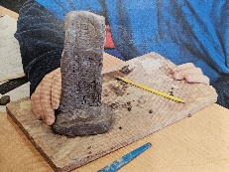 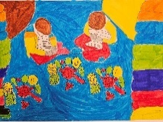 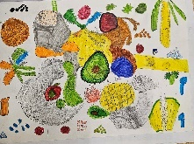 |  | Cross Curricula Link: Geography & History – London  Enrichment: Tate Modern/London visit  Children should be taught to:  Drawing (see Spring)  Collage  - Add collage to a painted or printed background  - Create and arrange accurate patterns  - Use a range of mixed media  - Plan and design a collage  Painting  - Create a colour palette, demonstrating mixing techniques  - Colour mix to explore harmonies, using the correct language  - Use colour to create atmosphere and light effects  - Explore complementary opposites and contrasting colours  - Use a range of paint for particular purposes  - Create different textures and effects with paint  - Develop a painting from a drawing  - Create compositions and select from 2 or 3 ideas  - Reflect upon their work inspired by a notable artist/designer/craft maker and the development of their skills  - Make observations about the work of notable artists/designers/craft makers  - Facts about the lives and work of notable artists/designers/craft makers  Key Vocabulary: perspective, horizon, silhouette, cityscape, landmark, landscape, blend, mix, line, tone, shape, tint, shade, matchstick men  Artists: Ken Done, Lowry  Suggested Outcomes: Street view, London landmark, London skyline, playground painting  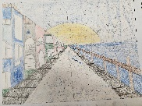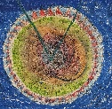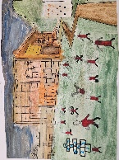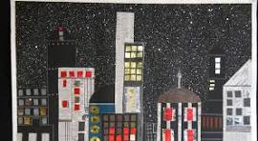
Year 6
Autumn – Drawing & Printing  KS2 Art and Design National Curriculum  To become proficient in drawing techniques.  To improve their mastery of art and design techniques, including drawing and printing, with a range of materials. |  | Spring – Painting  KS2 Art and Design National Curriculum  To become proficient in painting techniques.  To improve their mastery of art and design techniques, including painting with a range of materials. |  | Summer – Collage & Sculpture  KS2 Art and Design National Curriculum  To become proficient in sculpting techniques.  To improve their mastery of art and design techniques, including sculpture and collage with a range of materials.
Cross Curricula Link: History – WW1, PoR Stay Where You Are and Then Leave  Enrichment: WW1 Workshop  Children should be taught to:  Drawing  - Use a variety of techniques to add effects, e.g. shadows, reflection, hatching and cross-hatching  - Depict movement and perspective in drawings  - Use a variety of tools and select the most appropriate  - Use drawing techniques to work from a variety of  sources including observation, photographs and digital images  Printing  - Design and create printing blocks/tiles  - Develop techniques in mono, block and relief printing  - Create and arrange accurate patterns  - Reflect upon their work inspired by a notable artist/designer/craft maker and the development of their skills  - Make observations about the work of notable artists/designers/craft makers  - Facts about the lives and work of notable artists/designers/craft makers  Key Vocabulary: line, texture, pattern, form, shape, tone, smudge, blend, mark, hard, soft, light, heavy, sketching, shadows, reflection, hatching and cross-hatching, perspective, lino, printing, reduction, layering  Artists: Diane Sutherland, Janice Kirk – observational drawings  Suggested Outcomes: Observation drawings and lino prints of poppies  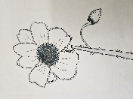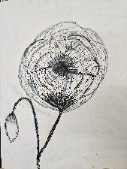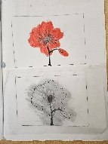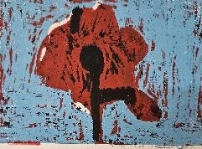 |  | Cross Curricula Link: Geography, PoR– Rooftoppers  Children should be taught to:  - Choose the type of paint and tools to use for a particular purpose  - Control and experiment with tones, shades and mood, building on previous knowledge  - Create compositions and select from 2 or 3 ideas  - Mix colour, shades, tints and tones to achieve an intended effect  - Create different textures and effects with paint  - Develop an awareness of scale and proportion in their own work  - Reflect upon their work inspired by a notable artist/designer/craft maker and the development of their skills  - Make observations about the work of notable artists/designers/craft makers  - Facts about the lives and work of notable artists/designers/craft makers  Key Vocabulary: composition, arrangement, scale, proportion, pointillism, shading, blending, mix, line, tone, shape, tint  Artists: George Seurat  Suggested Outcomes: Eiffel tower paintings – pointillism  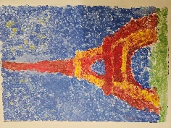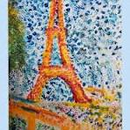 |  | Cross Curricula Link: History – Ancient Greece, PoR The Adventures of Odysseus  Enrichment: Exhibition for parents  Children should be taught to:  Collage  - Add collage to a painted or printed background  - Create and arrange accurate patterns  - Use a range of mixed media  Sculpture  - Manipulate materials to make a new 3D form based on a brief  - Add final finishes to models using paint/glazing techniques  - Use smoothing techniques to create a desired finish before painting  - Experiment with different forming techniques  - Experiment with different tools  - Create patterns to represent texture  - Reflect upon their work inspired by a notable artist/designer/craft maker and the development of their skills  - Make observations about the work of notable artists/designers/craft makers  - Facts about the lives and work of notable artists/designers/craft makers  Key Vocabulary: Amphora, Pyxis, Chytra, pottery, ancient, shards,sculpting, carving, malleable, kneading, wedging, pinch, coil, forming, slabbing, texture, patterns, decoration, technique, contrast,  Artists: various craft makers  Suggested Outcomes: Greek pots, Animal face collages 