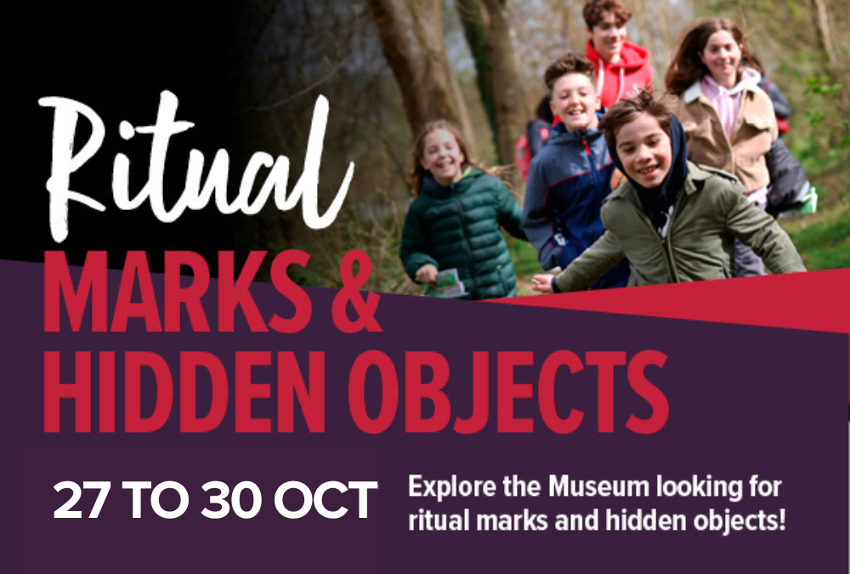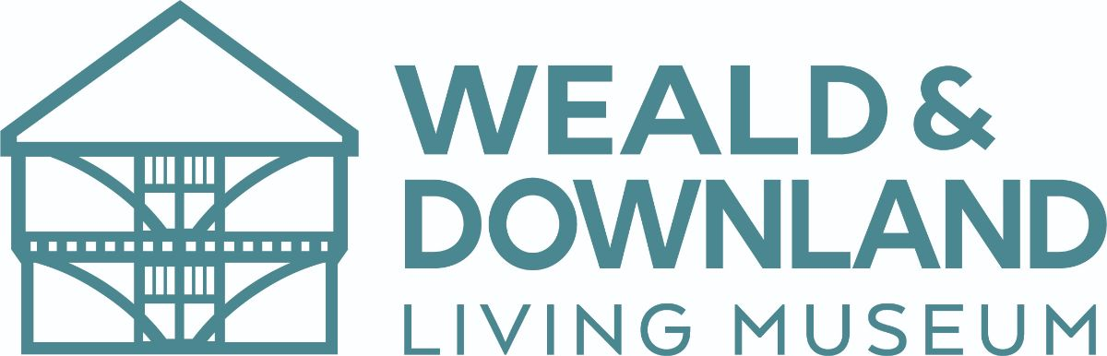

**October Half Term Fun**

**Ritual Marks and Hidden Objects – 27 to 30 Oct  
  
Explore the Museum this October Half Term!**  
  
Everyday over the half term you can explore our Ritual Marks and Hidden Objects Trail – Go on a spooky adventure to find ritual marks and hidden objects whilst learning about the folklore and superstitions of the past. Discover how they were believed to protect homes from the evil spirits!

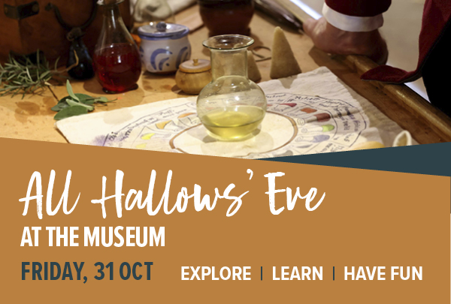

**All Hallows’ Eve**

**Friday, 31 October**  
  
Are you looking for something special, spooky and uniquely different to do to celebrate All Hollows’ Eve? Then look no further than a visit to the Museum this October 31. Upon arrival, pick up a spooky pass for £2 which will allow to take part in all four of our hauntingly historic activities. Collect a spooky stamp at each activity to complete your pass.

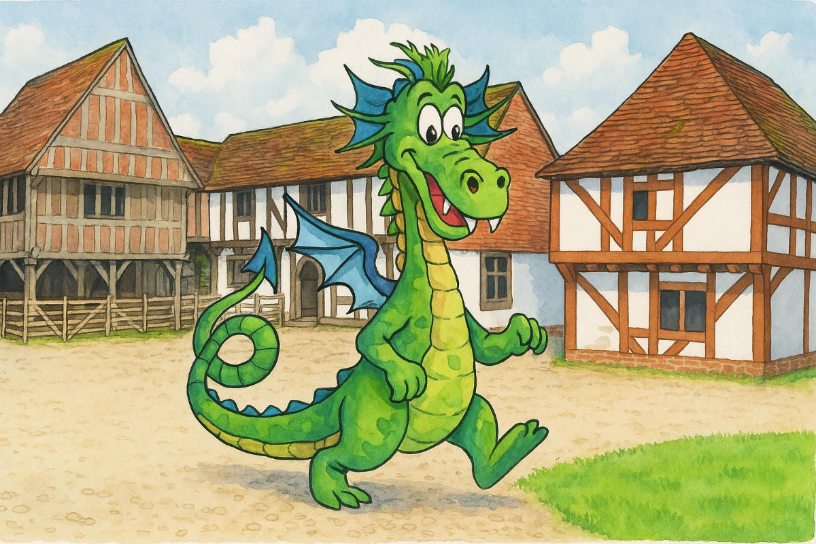

**Dinky Dragon’s Toddler Club**

Calling all curious explorers aged 2-4 years old, bring your adult for a rip roaring adventure at the Weald & Downland Living Museum. Knucker, our resident dragon puppet will take you on a journey of discovery exploring a different theme inspired by the Museum each session. Expect stories, songs, ‘make and take’ crafts and plenty of hands-on, free range fun in the great outdoors!  
  
The toddler club will run on selected Friday mornings, 10.30am to 12noon, during West Sussex term times. Each session has a different theme for the children to enjoy.  
  
**Friday, 7 November: Potion Commotion** – Do you like stirring, chopping, mixing and pouring? Then this potion themed session is for you. Experiment with different materials co make a gruesome concoction.  
  
**Friday, 12 December: Elves Toy Making Workshop** – Join this special festive themed toddler group to make some wonderful homemade toys to take home.