Examples of Character descriptions to help you
Dink
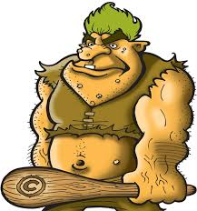
Deep inside the darkest cave lived a hideous creature known as Dink. Covered from head to toe in grotesque white pimples and crusty mud soaked skin, you can smell Dink before you can EVEN see him. On the very top of his head lives a family of lice that play all day in his bright green, unwashed hair. His enormous muscles escape from his tiny clothes which are soaked in sweat. Not only is Dink disgusting he also has a terrible attitude.

Annabella
On the very top of a magical mountain lived an enchanting and beautiful princess called
Annabella. Her auburn hair was thick, shiny and glossy and tumbled down her shoulders in waves. She wore a crimson dress that glistened in the light and long, silk, pink gloves on her tiny hands. Annabella was quite a shy girl that blushed when talking.
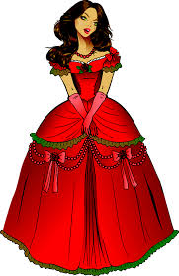

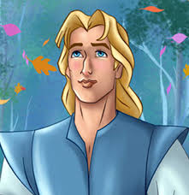
George
In a mystical forest was an old wooden house and in that house lived a handsome young man named George. His charming and friendly attitude meant that he was extremely likeable and he had lots of friends. He had bright blonde hair and crystal blue eyes that twinkled in the moonlight. George was an adventurous man who loved to go on dangerous quests.

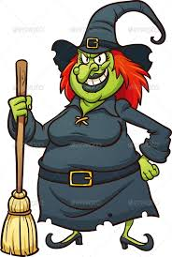
Wanda
Wanda, a wicked and selfish witch, was plotting a plan as usual. She cackled and sang (although very badly) as she stirred her cauldron. Her enflamed orange hair tangled and brittle like her mop. Dark black lipstick covered her lips and half of her teeth. Her ragged dress was filthy with ash from her dusty cauldron. Wanda was extremely rude and hated people.

