E4S KS1 Families and Friendships – Special People

Cornerstone: | RSE
Concept: | Families and friendships
Theme: | Special people
Key Questions: | Teachers have used the questions and statements from the E4S curriculum to plan lessons on being safe, which are delivered throughout the year according to the school’s scheme of work.  This is what your child will be learning about in the upcoming scheme of work:  - Who are our special people?  What makes them special to us?  - How do people look after each other?  - How can we help the people who look after us?  - What does family mean to me?  - How do I like to be treated by people in my family?  - What are the different ways we can show that we love someone?  - What is appropriate behaviour in different relationships?
Questions to consider with your child: | Who is in our family?  What makes our family special?  How is our family the same and different to other families?  How do we treat each other in our family?  How do we show each other love in our family?  What other relationships do you have?  How are our family relationships different to other relationships we have?
Suggested Resources for parents: | Please find additional support and guidance below in relation to families and friendships.  Healthy Relationships  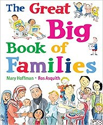  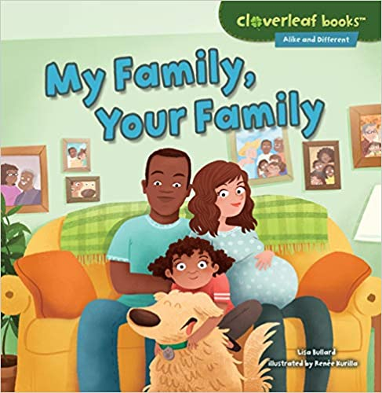  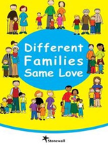  My Family, Your Family  All About Families  The Great Big Book of Families

