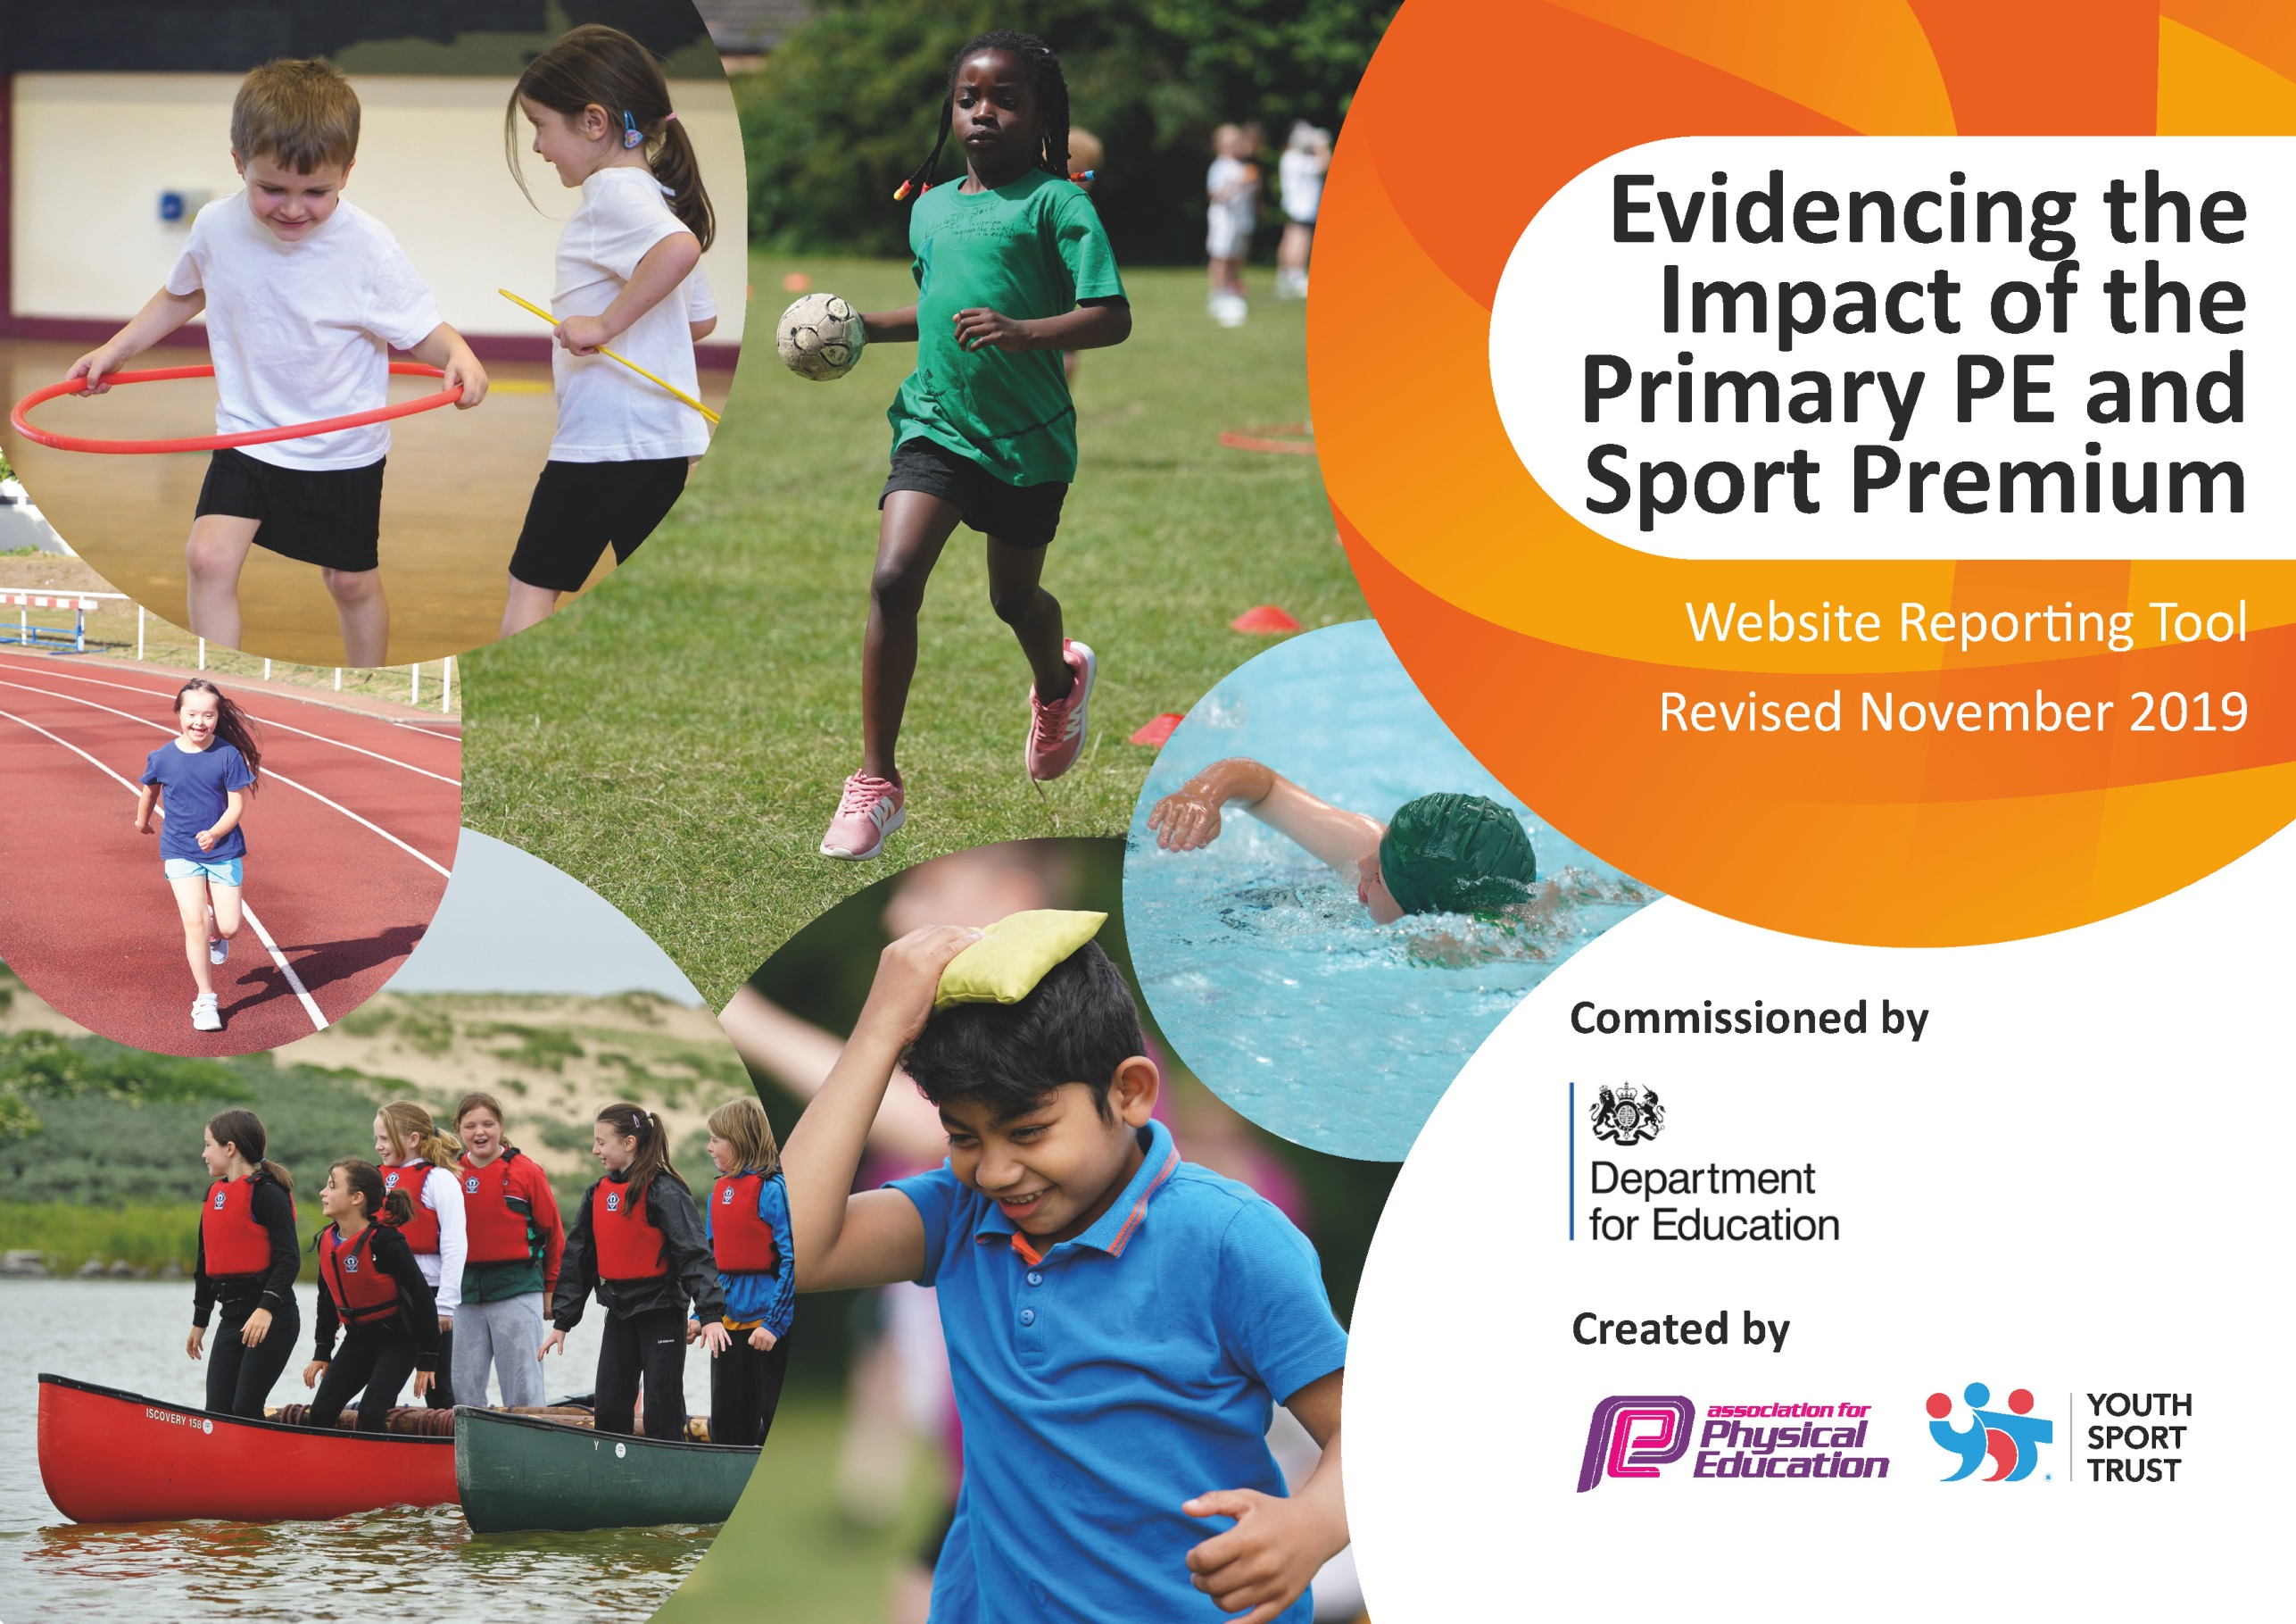
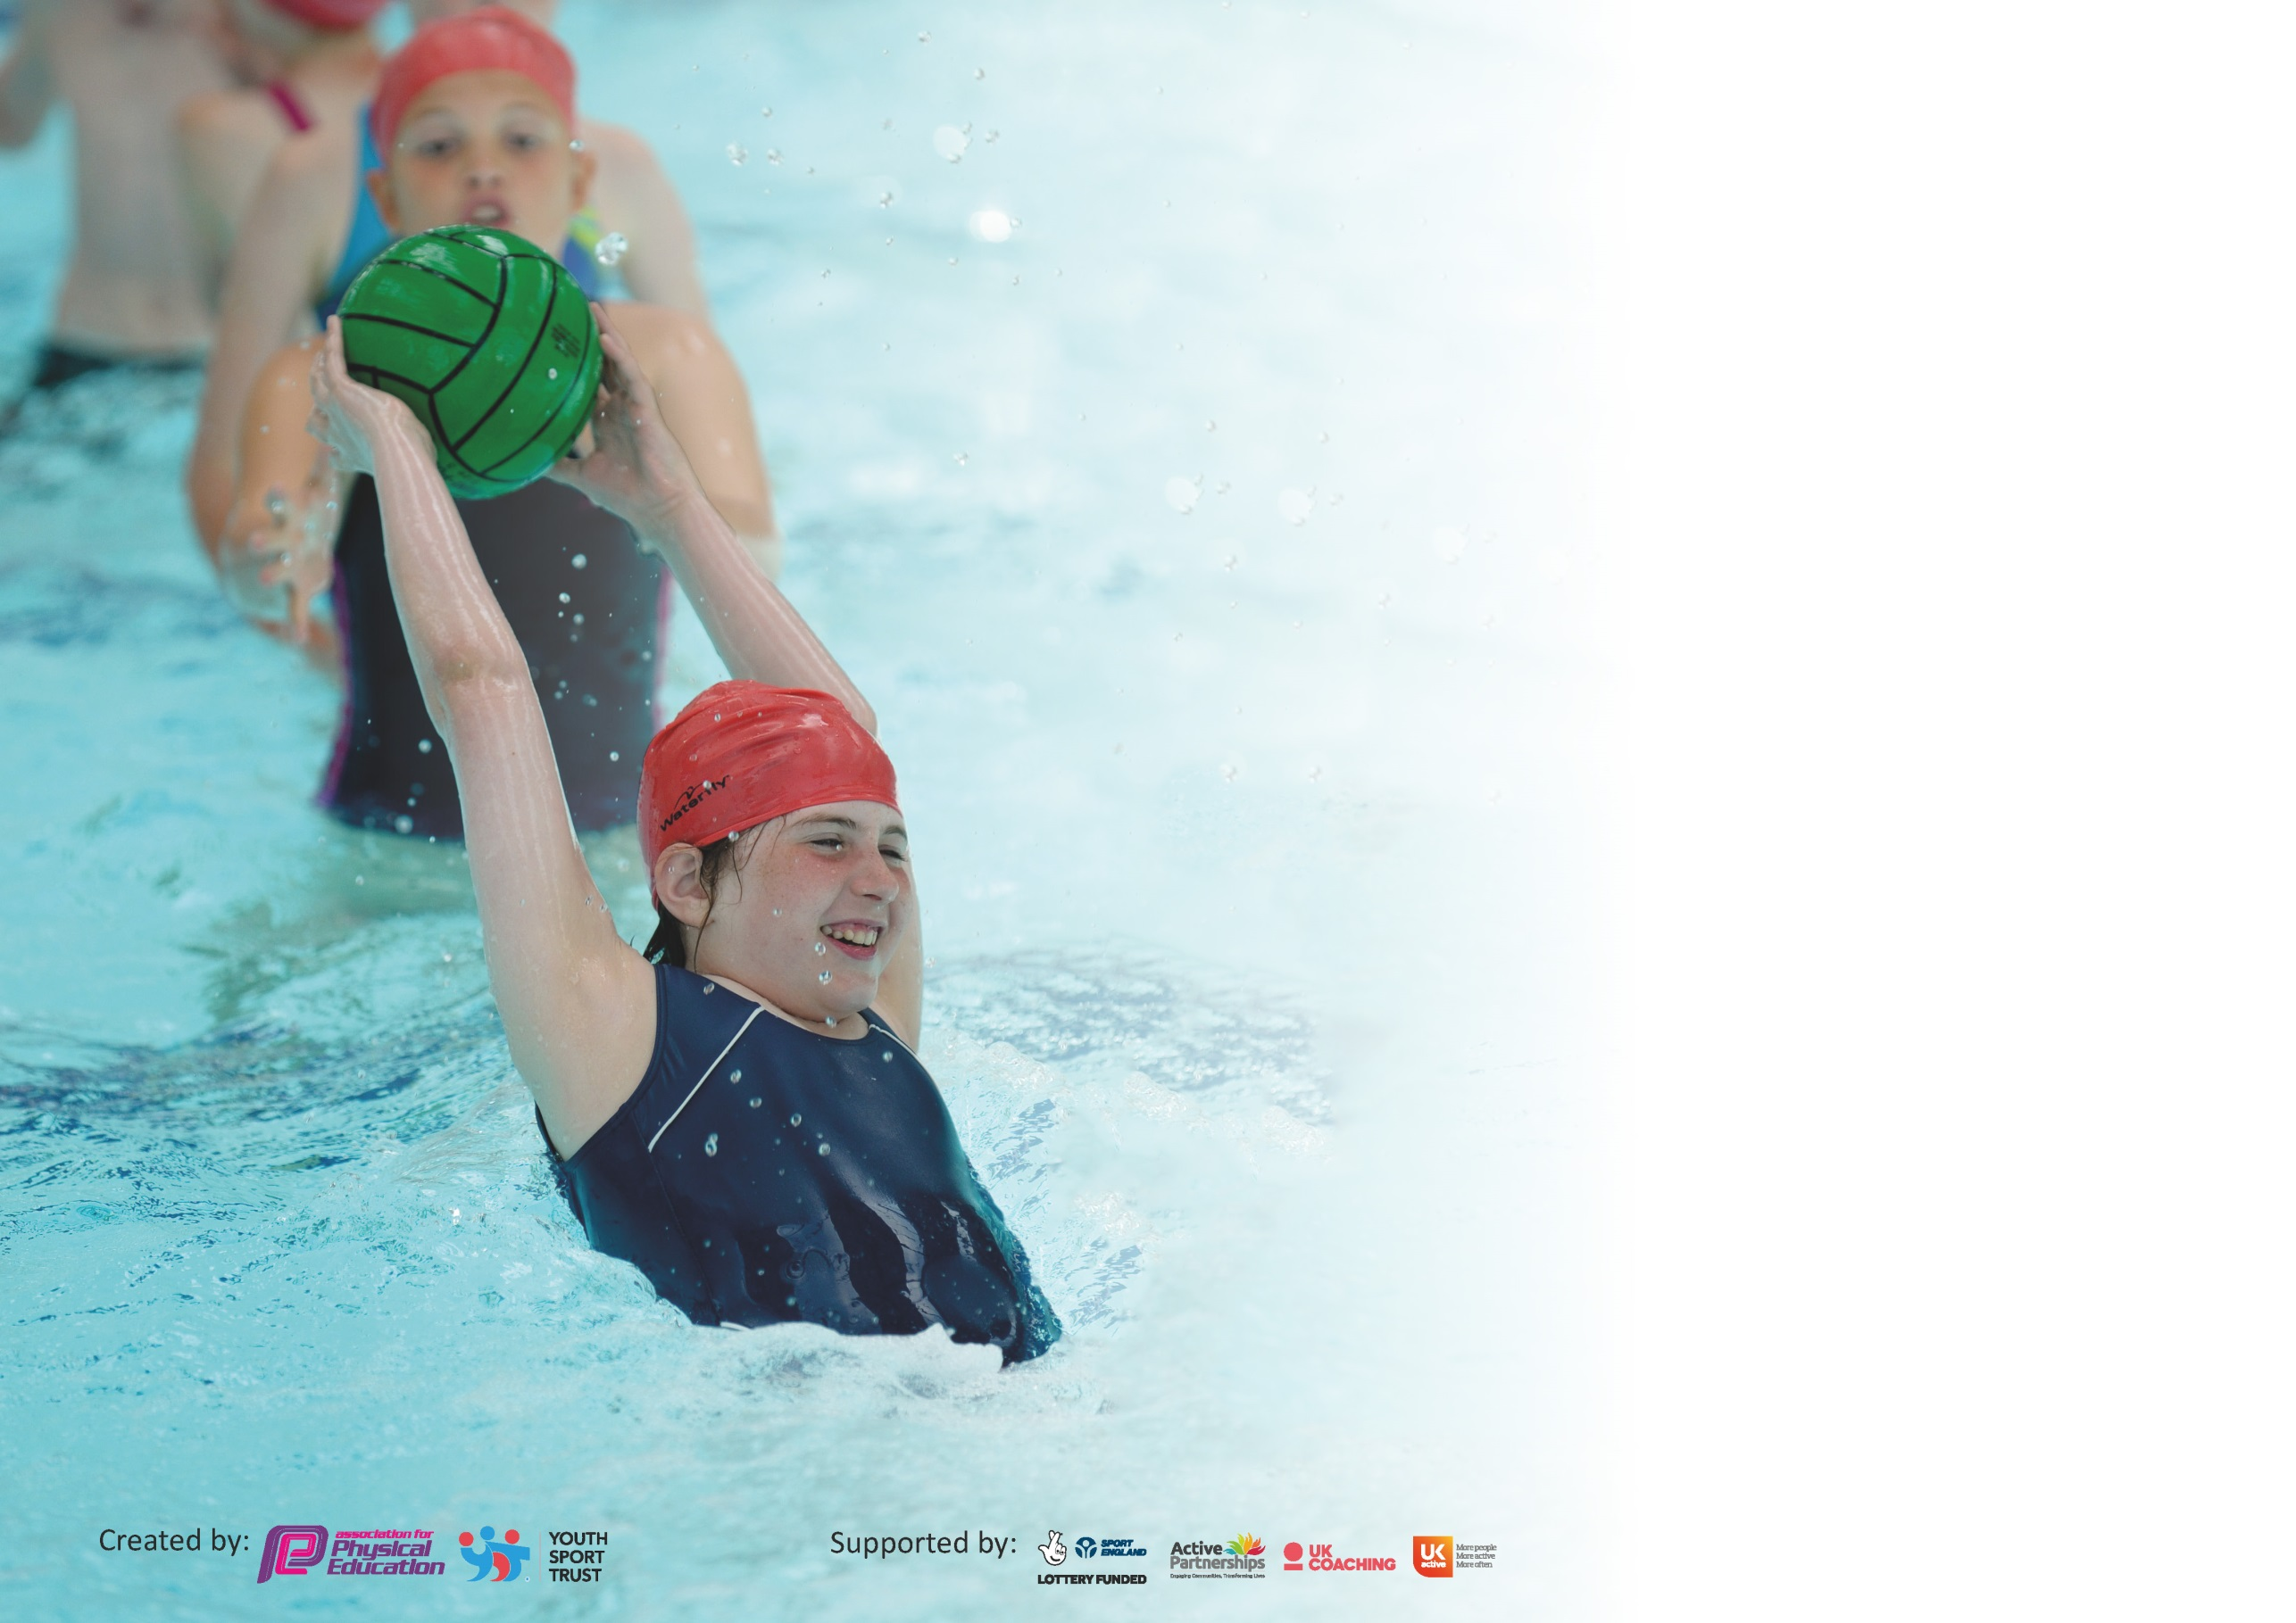

It is important that your grant is used effectively and based on school need. The Education Inspection Framework (Ofsted 2019 p64) makes clear there will be a focus on ‘whether leaders and those responsible for governors all understand their respective roles and perform these in a way that enhances the effectiveness of the school’.

Under the Quality of Education criteria (p41) inspectors consider the extent to which schools can articulate their curriculum (INTENT), construct their curriculum (IMPLEMENTATION) and demonstrate the outcomes which result (IMPACT).

To assist schools with common transferable language this template has been developed to utilise the same three headings which should make your plans easily transferable between working documents.

Schools must use the funding to make additional and sustainable improvements to the quality of Physical Education, School Sport and Physical Activity (PESSPA) they offer. This means that you should
use the Primary PE and Sport Premium to:

- Develop or add to the PESSPA activities that your school already offer
- Build capacity and capability within the school to ensure that improvements made now will benefit pupils joining the school in future years

Please visit gov.uk for the revised DfE guidance including the 5 key indicators across which schools should demonstrate an improvement. This document will help you to review your provision and to report your spend. DfE encourages schools to use this template as an effective way of meeting the reporting requirements of the Primary PE and Sport Premium.

We recommend you start by reflecting on the impact of current provision and reviewing the previous spend.

Schools are required to publish details of how they spend this funding as well as on the impact it has on pupils’ PE and sport participation and attainment by the end of the summer term or by 31st July 2020 at the latest.

We recommend regularly updating the table and publishing it on your website throughout the year. This evidences your ongoing self-evaluation of how you are using the funding to secure maximum, sustainable impact. Final copy must be posted on your website by the end of the academic year and no later than the 31st July 2020. To see an example of how to complete the table please click HERE.

Support for review and reflection - considering the 5 key indicators from DfE, what development needs are a priority for your setting and your pupils now and why? Use the space below to reflect on previous spend and key achievements and areas for development.

Key achievements to date until July 2019: | Areas for further improvement and baseline evidence of need:
The engagement and increase of pupils in regular physical activity. The new play equipment in the playground, which is coordinated by lunchtime staff, and the excellent Sports Crew that we currently have who run activities every lunchtime.  Forest School has been a huge success at Holy Trinity. It is currently run by a KS1 teacher who spends Friday each week doing a morning and afternoon of Forest School with a year group.  The broader experience of a range of sports and activities offered to all. Over the past few years the children have experienced, trampolining, golf and badminton. This year we have had a focus on cricket after the enthusiasm amongst the children after the success of the England Cricketers.  Increased participation in competitive sport. We have tried to enter as many MSA events, or other cluster events, as possible over the last two years.  Orienteering course set up on the school grounds.  Focused teacher training on gymnastics and dance which had been two areas that had been identified as areas that teachers felt less confident teaching. | Further development of the PE Curriculum and PE assessment systems. Having introduced a scheme of work to ensure progression, a separate curriculum document is being developed to ensure that all areas are being covered and that there are opportunities for progression for all children. An assessment document (alongside Target Tracker) is also being created to give a better picture of the children that may need extra support of different opportunities to encourage them to be active.  Continue to work with our PE specialist to ensure high quality teaching. Ensure that this is sustainable CPD by development of teachers’ confidence, skill set and knowledge. Furthermore, use this CPD to improve the curriculum document that is being created.  Discuss with staff and children if there are daily activities that could be introduced that are workable and sustainable - ideas include, the daily mile, yoga in the classroom, a quick hit of exercise such as with Joe Wicks (10-15 mins).  Continue to raise the profile of sport in the school. Sports Crew board, Sporting Achievement board, information about festivals and competitions in the newsletter. Give more status to events such as Sports Relief.  Ensure that the pupils are being given a voice in the decision making about PE. This was started during school Council meeting at the start of the Spring Term, where the possibility of the children participating in trampolining was suggested.  Continue to develop Sports Day so that there is increased participation by all pupils and an opportunity for competitive sport.  To work with an organisation such as Albion in the Community to help promote the idea of Healthy living.  Initiative to help children to understand the difference between PE, Sport and Physical Activity.  Pupil survey to determine what percentage of pupils are taking part in physical activity out of school hours. (Data collected at the beginning of the year).

Meeting national curriculum requirements for swimming and water safety.
What percentage of your current Year 6 cohort swim competently, confidently and proficiently over a distance of at least 25 metres?  N.B. Even though your pupils may swim in another year please report on their attainment on leaving  primary school at the end of the summer term 2020. | 83%
What percentage of your current Year 6 cohort use a range of strokes effectively [for example, front crawl, backstroke and breaststroke]? | 83%
What percentage of your current Year 6 cohort perform safe self-rescue in different water-based situations? | 83%
Schools can choose to use the Primary PE and Sport Premium to provide additional provision for swimming but this must be for activity over and above the national curriculum requirements. Have you used it in this way? | No

Action Plan and Budget Tracking
Capture your intended annual spend against the 5 key indicators. Clarify the success criteria and evidence of impact that you intend to measure to evaluate for pupils today and for the future.

Academic Year: 2019/20 | Total fund allocated: £ | Date Updated:
Key indicator 1: The engagement of all pupils in regular physical activity – Chief Medical Officer guidelines recommend that primary school pupils undertake at least 30 minutes of physical activity a day in school |  |  |  | Percentage of total allocation:
 |  |  |  | %
Intent | Implementation |  | Impact
Your school focus should be clear what you want the pupils to know and be able to do and about  what they need to learn and to  consolidate through practice: | Make sure your actions to achieve are linked to your intentions: | Funding allocated: | Evidence of impact: what do pupils now know and what can they now do? What has changed?: | Sustainability and suggested next steps:
To create an exciting, safe and engaging play area for KS1 children where they can develop their gross motor skills, climbing skills and ability to play outdoor games with other children. This would be to replace the existing KS1 Ship.  To make a safe play area outdoors for the children in Reception meaning that they are able to be more active outdoors.  To provide a classroom based physical activity that can be used as a short mental break or when the outside space cannot be used due to bad weather – ice or heavy rain.  To encourage children to engage in particular exercises during playtimes. These exercises can also be used as part of PE lessons and warm ups or circuit training.  To ensure that there is enough of the correct equipment needed for lessons. | The school bursar, Natalie Hay has discussed the plans with Governors and the headteacher, Ann MacGregor.  Several design options have been considered.  New outdoor equipment flooring under clamber stacks in the Early Years outdoor area.  Nathalie Hay discussed with Ann MacGregor and the Early Year Team.  Implementation of Jump Start Jonny which can be used in all classrooms.  Sports activity boards being placed around the playground.  Subject leader and the caretaker discussed the positioning of the boards and the boards were due to be put up during the Easter Holidays.  Specialist teacher and Sports Crew have carried out an initial tidy and clear out of the PE cupboard. | TBC  £1800 (from 2018-2019 budget  £259  N/A  TBC | This area is used daily by the children in Reception. They are able to use it during their outdoor time. It means that they now have a physical activity to do and achieve on.  Many classes use this now as a brain break activity or will use it as some heart pumping activity if there has been no outdoor play. Teachers have reported that this has been helpful to help with children’s ability to concentrate. | The subject leader will discuss with the Early Years Team, the possibility of specific activities being designed which encourages the children to use their bodies in certain ways.  Consider the other classroom -based activities that can be used in the classroom alongside or instead of Jump Start Jonny. These activities can help to ensure that every child is undertaking at least 30 minutes of physical activity every day.  Conduct a survey to see which classes are using Jump Start Jonny.  Subject leader to carry out an audit of the PE cupboard and to order additional items that are needed.
Key indicator 2: The profile of PESSPA being raised across the school as a tool for whole school improvement |  |  |  | Percentage of total allocation:
 |  |  |  | %
Intent | Implementation |  | Impact
Your school focus should be clear what you want the pupils to know and be able to do and about  what they need to learn and to  consolidate through practice: | Make sure your actions to achieve are linked to your intentions: | Funding allocated: | Evidence of impact: what do pupils now know and what can they now do? What has changed?: | Sustainability and suggested next steps:
For the Sports Crew to run activities every lunchtime which they have planned, organised and then carry out. This is an opportunity for Year 6 to have pupil voice and develop their leadership skills. To provide an additional structured exercise opportunity for children across KS1 and KS2.  Increased profile of active travel to school.  To continue to raise the profile of sport and PE in the school:  To create a Sport/PE board and Sports Crew Board Board – a celebration of all the sports that are taking place in the school, lessons, competitions, special visitor sessions, sports specialist sessions and Sports Crew sessions  More information being available on the school’s website and in the school newsletter about the events that have taken place.  To increase Pupil Voice input about sporting activities. | Subject Leader and Year 6 pupils attending the Sports Crew Training.  Abi Eliff, the school’s specialist teacher, met with the pupils to help them to structure their activities.  The Sports Crew created posters and spoke about the activities in an Achievement Worship.  Taking part in the walk to school survey which has raised awareness amongst the children about how they travel to and from school.  A board for the Sports Crew has been set up. Posters have been designed to tell the other children about the Sports Crew sessions – when they are happening and which activity.  A board with the events and photographs of the children taking part in various events has been created.  Events and photographs are being included in the school newsletter which is created by Ann MacGregor.  The School Council were asked for their views on areas such a Sports Day, activities in the playground and other sporting events that they would like to be run. The councillors then gathered the views of their classmates. | TBC  N/A  N/A  N/A | The number of children that are now engaged in a structured physical activity during playtimes has increased. There is a variety of activities to join in with. The Year 6 sports crew members are running the sessions independently. | This is one of the most crucial areas in raising the profile of sport and being active in the school. The children taking the lead and showing other children how to be active.  To train year 5’s to help.  To ask sports crew to help during PE lessons (after SATs).  To potentially create another tier of sports leaders throughout the school.  Subject leader/Sports Crew to carry out a survey to find out how many children across the school are engaging in the activities.  Gather data  Subject leader to discuss with the School Office Manager further additions of photographs on the website.  The views need to be fed back to the PE lead and considered in terms of the design of Sports Day and any further sporting events.

Key indicator 3: Increased confidence, knowledge and skills of all staff in teaching PE and sport |  |  |  | Percentage of total allocation:
 |  |  |  | %
Intent | Implementation |  | Impact
Your school focus should be clear | Make sure your actions to | Funding | Evidence of impact: what do | Sustainability and suggested
what you want the pupils to know | achieve are linked to your | allocated: | pupils now know and what | next steps:
and be able to do and about | intentions: |  | can they now do? What has
what they need to learn and to |  |  | changed?:
consolidate through practice:
To improve the confidence of teachers when teaching PE and Sport.  To improve the quality and progression of teaching.  To improve the quality of the activities that the Sports Crew are offering.  Further staff training:  To consider whether a new scheme of work is something that would enhance the teaching of PE at Holy Trinity.  To attend courses looking at the best use of the Sports Premium money and courses such as inclusion for all children.  To consider the new way that PE will be inspected and the expectations that need to be met.  NQT training to increase the teacher’s knowledge base and confidence.  To increase the teacher’s confidence to use dance in Reception, to link with learning and to help the children to improve their gross motor skils  To ensure implementation and sustainability of Sports Premium Funding, organisation of events/administration in relation to the School Games Mark, development of curriculum and assessment documents. | The school is employing Abi Eliff from JASC Sports-Specialist PE teaching  Abi is modelling excellent teaching in areas that have been identified an area in need of training across the staff. Initially dance and gymnastics and has now moved to other areas of the PE curriculum, Football – so to find a better way to differentiate for those children who already play football.  Tag rugby - a skill that teacher’s felt unsure how to teach effectively.  KS1 ball skills  Abi has helped train and run the Sports Crew enabling them to develop their leadership skills and to provide an opportunity for them to have pupil voice.  Abi has helped monitor the curriculum coverage and has made suggestions about how to track the progression and attainment of the children.  Subject Leader – Real PE training  PE Conference (best practice)  Ofsted Deep Dive Course  Year 3 teacher – First Steps Invasion Games, First Steps Dance  Year 2 teacher – Outdoor learning  Reception teacher – First Steps Dance  Subject Leader time  2 hours per week | £6500  TBC  £2413 | The confidence of teachers has grown hugely having had Abi demonstrating and team teaching with them. The enthusiasm for PE is higher and the two lessons of PE (indoor and outdoor) are being consistently taught across the school. The children are being taught to a higher standard, with clear learning challenge and success criteria and well structured lessons.  The number of children that are now engaged in a physical activity during playtimes has increased. The year 6 sports crew members are running the sessions independently.  The curriculum is being developed to ensure that progression is taking place across all year groups. An assessment document is being developed. The curriculum document is being developed to ensure that all teaching staff are aware of the link between the healthy body and healthy mind. We are looking at ways of how to create a clearer curriculum link between PE, PSHE and pupil wellbeing, including Forest School.  The decision was taken not to implement this scheme and to continue to work with JASC Sports-Specialist PE teaching.  Ideas gathered for new activities.  Development of curriculum and assessment underway.  Activity ideas and teaching strategies used in lessons, meaning that the children are getting high quality teaching using fresh ideas.  Activity ideas and teaching strategies used in lessons, meaning that the children are getting high quality teaching using fresh ideas.  Continuing to ensure that the Sports Premium money is being spent effectively and sustainably. Provision of opportunities for all children to attend events. Creation of a curriculum that shows progression and identifies areas that need development for both children and teachers. | To continue to ensure that areas of teaching that need to be developed are identified through a staff survey. These areas then need to be discussed with and then implemented by Abi.  Short teaching observations by Abi to give feedback to teachers about areas that they could develop further. Ideally this will work through a four lesson cycle of two lessons where the teacher observes Abi, one where they team teach and one where the teacher leads the lesson.  The PE to continue to work closely with Abi to develop the curriculum through a combination of bespoke lessons created by Abi and the use of the PE hub scheme of work.  Ideas to be shared in PE staff meeting (postponed due to school closures).
Key indicator 4: Broader experience of a range of sports and activities offered to all pupils |  |  |  | Percentage of total allocation:
 |  |  |  | %
Intent | Implementation |  | Impact
Your school focus should be clear | Make sure your actions to | Funding | Evidence of impact: what do | Sustainability and suggested
what you want the pupils to know | achieve are linked to your | allocated: | pupils now know and what | next steps:
and be able to do and about | intentions: |  | can they now do? What has
what they need to learn and to |  |  | changed?:
consolidate through practice:
To encourage more children to play cricket at festivals competitions and at local clubs, especially those children that perhaps are less active or are not interested in football.  Tag rugby is an area that was identified as an area of development for the teachers but also there are several tournaments and festivals that we wanted the children to feel more confident about attending.  Additional achievements: | Sussex Cricket working with Year 3  Sussex Cricket working with KS1 – postponed due to school closures  Ardingly College cricket outreach working with Year 4 -postponed due to school closures  Sports Specialist working with teachers on Tag Rugby | N/A  See above | Children showing a real keenness to play cricket, including joining in with the sports crew when they run it. Some children signing up to play during the season with All Star Cricket. First competitive cricket competition went well with the school winning 3 out of 4 games. Further events postponed due to school closures.  Tournaments and festivals currently postponed due to school closures. | Continue to build our school’s relationship with Sussex Cricket, particularly for the lower KS2 and KS1. We attend the festivals and tournaments run by Sussex Cricket, particularly for upper KS2.

Key indicator 5: Increased participation in competitive sport |  |  |  | Percentage of total allocation:
 |  |  |  | %
Intent | Implementation |  | Impact
Your school focus should be clear | Make sure your actions to | Funding | Evidence of impact: what do | Sustainability and suggested
what you want the pupils to know | achieve are linked to your | allocated: | pupils now know and what | next steps:
and be able to do and about | intentions: |  | can they now do? What has
what they need to learn and to |  |  | changed?:
consolidate through practice:
To continue to increase pupil participation in, and enjoyment of, competitive activities.  To continue to develop a variety of children’s ability to  lead and organise sporting activities  Support for subject leader and in turn the subject leader is able to  confidently support and guide teaching staff. | MSA Partnership - continued membership with Mid Sussex Active.  Mid Sussex Active provide:  extensive quality assured professional development programme for teaching staff  access to a wide range of inter- school competitions and festivals for children from R – Yr6  training to develop young people as sports leaders  specialist advice and support from our local secondary schools  support, training and  networking opportunities for PE  co-ordinator and other members of staff.  see www.midsussexactive.org.uk for further information and reports about events/training/calendar etc | £5400 (for two years) | This will be evidenced through the data gathered of how many children attended MSA or cluster events. This data will be added to this document at the end of the academic year.  See above for the evidence in relation to the impact of the Sports Crew and the involvement of School Council.  Support received from Active Sussex in terms of Sports Premium documentation.

Signed off by
Head Teacher:
Date:
Subject Leader:
Date:
Governor:
Date:

