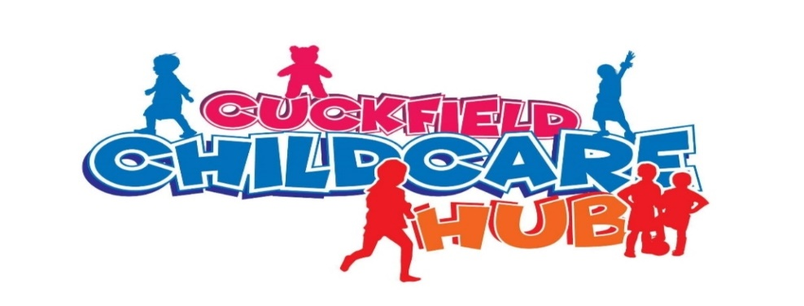

SUMMER HOLIDAY CLUB DETAIL
- Our summer kids club is running from the 24th July-13th August & 26th- August-30th August we are open from 7:30 am – 6pm.
- Every day the kids can pick from a variety of activities ranging from arts, crafts, cooking, slime making, sushi making, sports and team activities.
- Each day a choice of activities is laid out and the kids can make their own choices of what they would like to enjoy on that day.
- Between activities there is lots of time to take a break with snack times and a lunch break.
- There will also be nature walks, picnics and outings on a variety of days

Our Prices-
8am-5pm | 9am-5pm | Half day 9am-1pm or 1pm-5pm
£32 | £29 | £17
Additional hours | £6 PH | £6 PH
A discount of 5% is applied to the youngest of any siblings and all fees are payable in advance.
Children should be provided with a drinks bottle and a packed lunch by parents. A healthy dinner will be provided for any bookings until 6pm.
This Photo by Unknown Author is licensed under CC BY-SA-NC

TO BOOK PLEASE CALL 07504951251 OR EMAIL CUCKFIELDCHIDCAREHUB@OUTLOOK.COM

