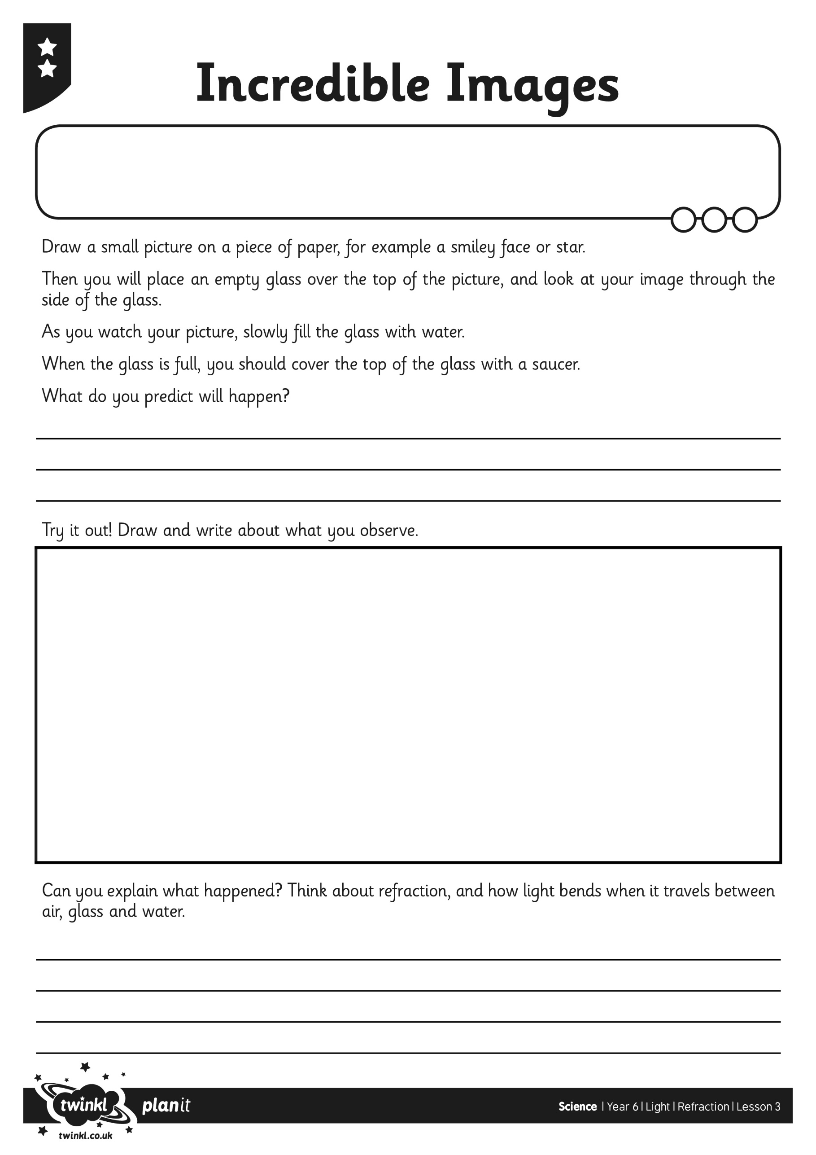

I can investigate the effects of refraction.

I can understand the way refraction alters the direction of light.