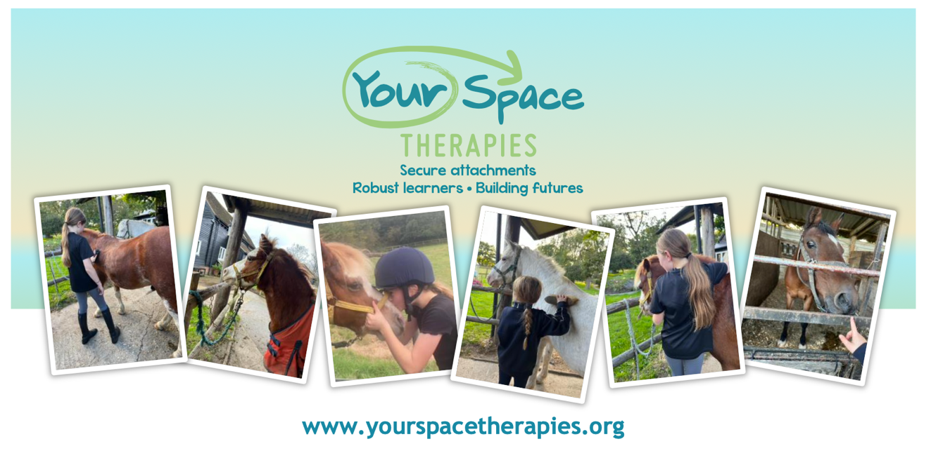
🌼 October Half Term Mindfulness Pony Day for Kids! 🌼
Date: Wednesday 29th October 2025
Time: 9am- 2pm
Location: Ponies ‘n’ Kids, Eaton Thorne Stables, Woodmancote, Nr Henfield, W.Sussex, BN5 9AG
Join us for a magical day designed especially for children ages 5-11! Dive into a world of peace, friendship, and mindfulness, all while experiencing the calming presence of our adorable ponies.
✨ What to Expect:
💖 Mindfulness Time with Ponies: Learn calming techniques and emotional regulation skills while spending quality time with our gentle ponies.
🦄 Pony Care: Discover the joys of caring for ponies through grooming, feeding, and building a bond.
🏇 Riding and Mounted Games: Experience the joy of pony rides and engage in fun, team-based games that promote confidence and cooperation.
🌳 Connect with Nature: Immerse yourself in the tranquillity of our beautiful, quiet stables and serene surroundings.
🎉 Make New Friends: Build connections and friendships with other children in a supportive, nurturing environment.
Scan the QR code or click this link to book: Mindfulness Pony Day 29th October 2025

Cost: £140 per child
Spaces limited to 15 children

We are an inclusive team and warmly welcome children with Special Educational Needs and Disabilities (SEND). We celebrate diversity and are committed to providing a supportive environment where every child can thrive.

