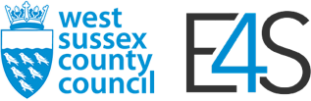 | 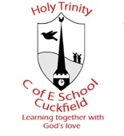

E4S Case Study

Holy Trinity CE (A) Primary School
Holy Trinity CE (A) Primary School is located in the village of Cuckfield and currently has 418 children on role from EYFS to year 6. Although the school has had a PSHE curriculum in place for many years, it didn’t fully meet the needs of the children and wasn’t always delivered consistently across the year groups. To raise the profile of PSHE and to ensure that the curriculum was age appropriate and fully met the needs of the children, the RSHE lead introduced E4S to the school two years ago and after an in-depth consultation process, launched the new curriculum in September 2021.
The first stage was to develop a policy which clearly defined RSHE and supported all staff in the delivery of good quality teaching and learning. Once the policy had been outlined, a consultation process took place which allowed all stakeholders in the school community to contribute to the development of the policy. On completion of the process, parents were asked for their views. One parent wrote
‘It is a good document - clearly explains what the pupils will be taught and the approach to teaching, answering children's questions, and safeguarding. Thank you!’

Another parent wrote ‘The policy looks very comprehensive and I approve of the focus on kindness and feeling safe - both as individuals with adults and amongst peers. My oldest child is in Y6 and so our household is going through this for the first time and I trust the teachers and professionals who have put this together from their experience and guidance from various sources. Thank you.’
The next stage was to assess the needs of our children which, again, involved all members of the school community. The data collected was used to identify the need and create a bespoke curriculum for our school using the E4S Curriculum Builder.
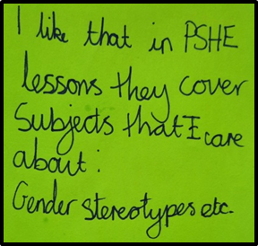 | 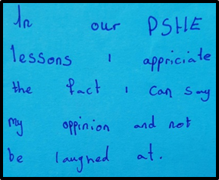
UKS2 pupil voice | UKS2 pupil voice

One year on, the new E4S/RSHE curriculum has been delivered consistently across the school in every year group from 1 to 6. Teachers completed a questionnaire at the end of the summer term to gauge staff confidence and competence and the results showed that the majority of teachers really enjoyed teaching PSHE and understand the value of it. A year 6 teacher said ‘I have really enjoyed planning the new curriculum this year, although it has been quite a lot of work. I know the areas that I need to develop in next year's planning e.g. aspects of RSE. I felt the curriculum was particularly relevant to the children given the discussions which are part of today's society - especially in preparing the Year 6 children for the transition to secondary school.’ A year 2 teacher said ‘I feel a lot more confident planning the PSHE now as I know it’s relevant for our children. The children have responded really well to our E4S lessons and I’m always impressed with how engaged they are. I think that’s because it’s relevant to them and they can see the value of what they are learning.’ During our pupil interviews in the summer term, SLT were overwhelmed by how confidently the children spoke about their learning and their level of understanding of the themes and concepts covered through the RSHE curriculum. A year 6 pupil said ‘I’ve realised that there are a lot more risks than I thought there were. We get to role-play scenarios and share our opinions about the choices we could make. It’s been really helpful, especially as we need to be more independent next year when we go to secondary school.’ A year 4 child said ‘We practise real-life scenarios which is really helpful. When you’re older, you need to know how to cope with these situations and how to be safe. It helps us to know what to do.’
 | 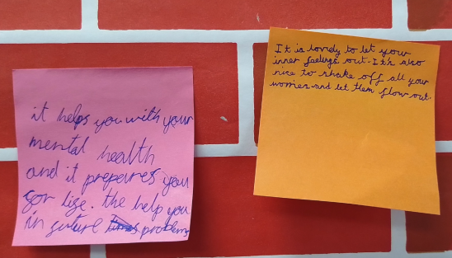
LKS2 pupil voice | LKS2 pupil voice

As the RSHE lead, I now feel confident that the curriculum we have in place is up to date and relevant for our children. However, we also recognise as a school, the importance of monitoring and reshaping the curriculum as appropriate, so that it continues to meet the needs of the children in our school. This is to ensure that the curriculum we have place teaches our children the knowledge and skills they need to thrive and to make informed decisions about their safety which will ultimately impact on their happiness, confidence and overall wellbeing. E4S has played a huge part in the development of this and fully supports what we are trying to deliver as a school.

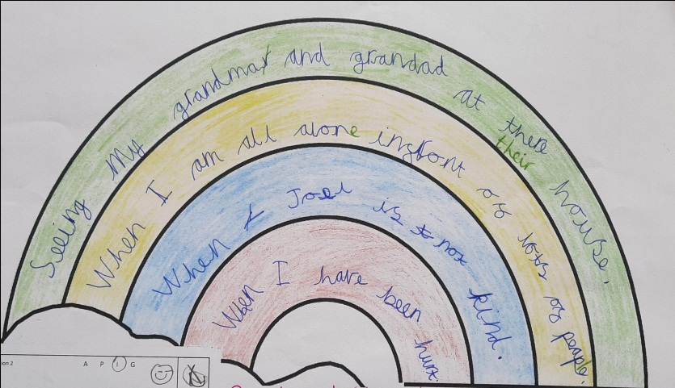
A KS1 child reflects on the things that make them feel happy, worried, sad and angry.

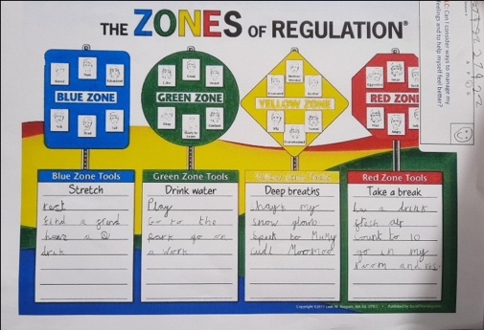 | 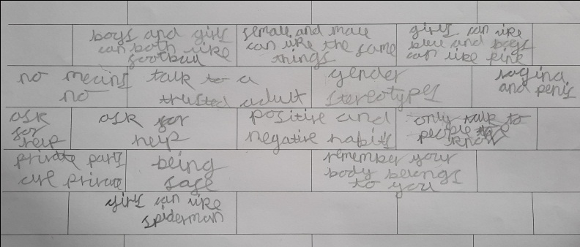
Creating a toolbox to help us cope with different feelings and emotions. | A graffiti wall completed by a year 2 child at the end of an RSHE unit of work.

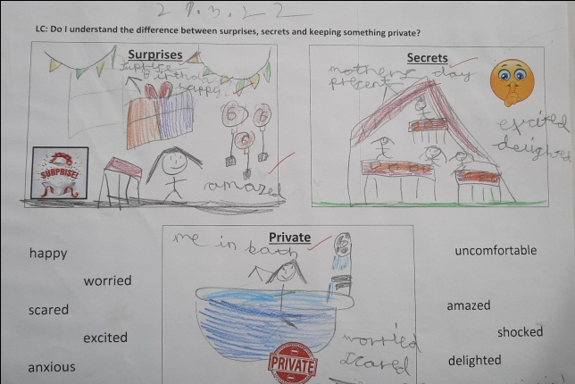
Learning the difference between surprises, secrets and privacy.

