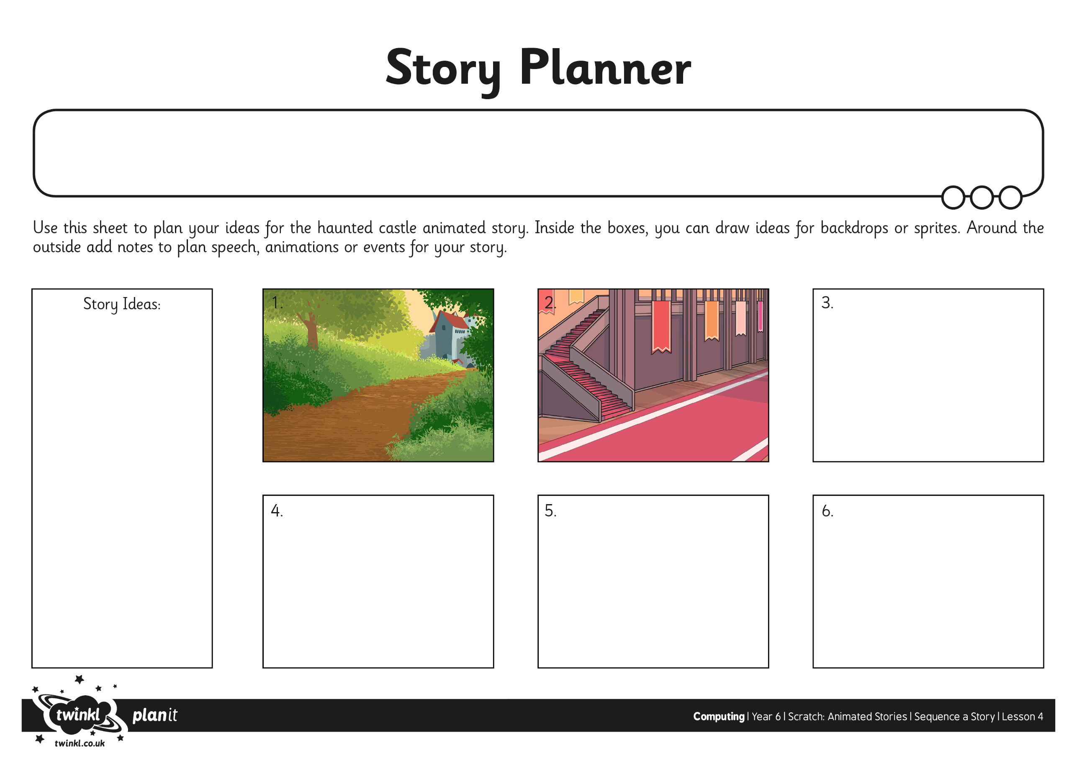

I can sequence events to create a story narrative.