Design then paint a pebble
https://www.youtube.com/watch?v=TuMezvSUGYw
Children could fold A4 sheet into 4 and draw round pebble to do 4 designs then choose favourite to do in paint

Tip : mix paint with PVA glue or you could paint whole pebble one colour (white) then paint with felt tips
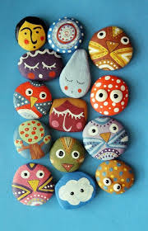
- Use PVA to varnish
