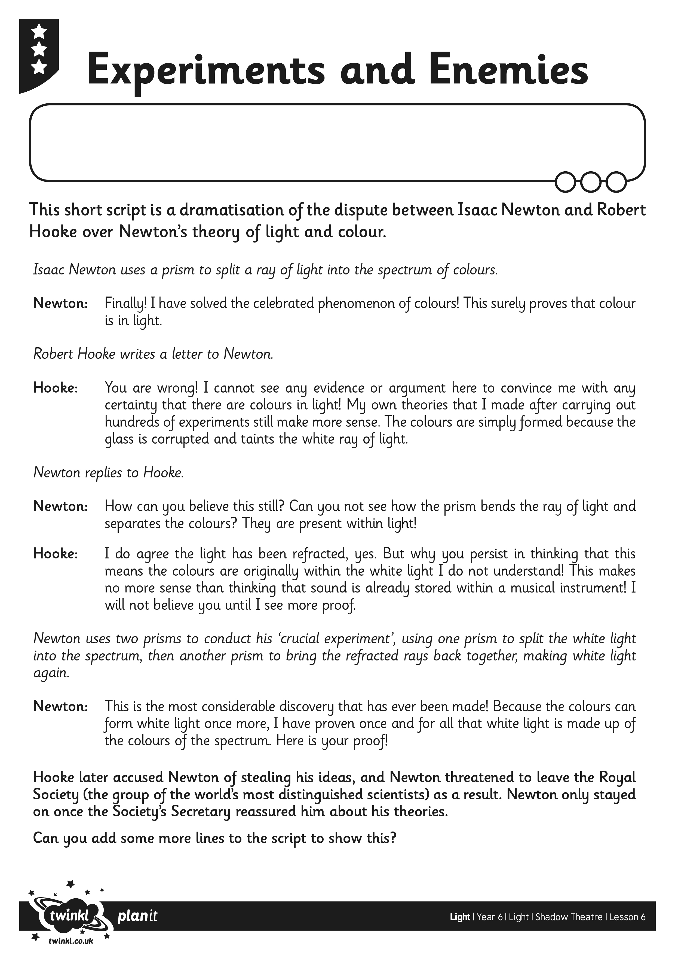
I can use my knowledge of light to create a shadow puppet play.

