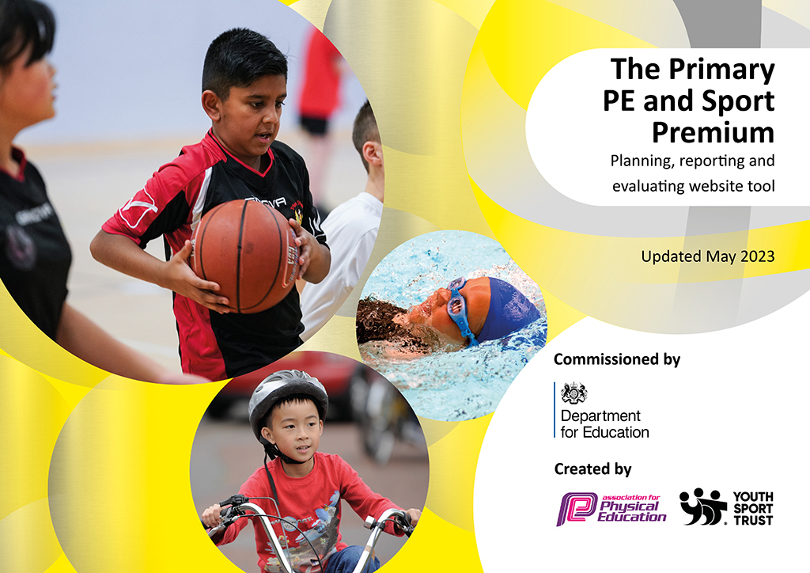
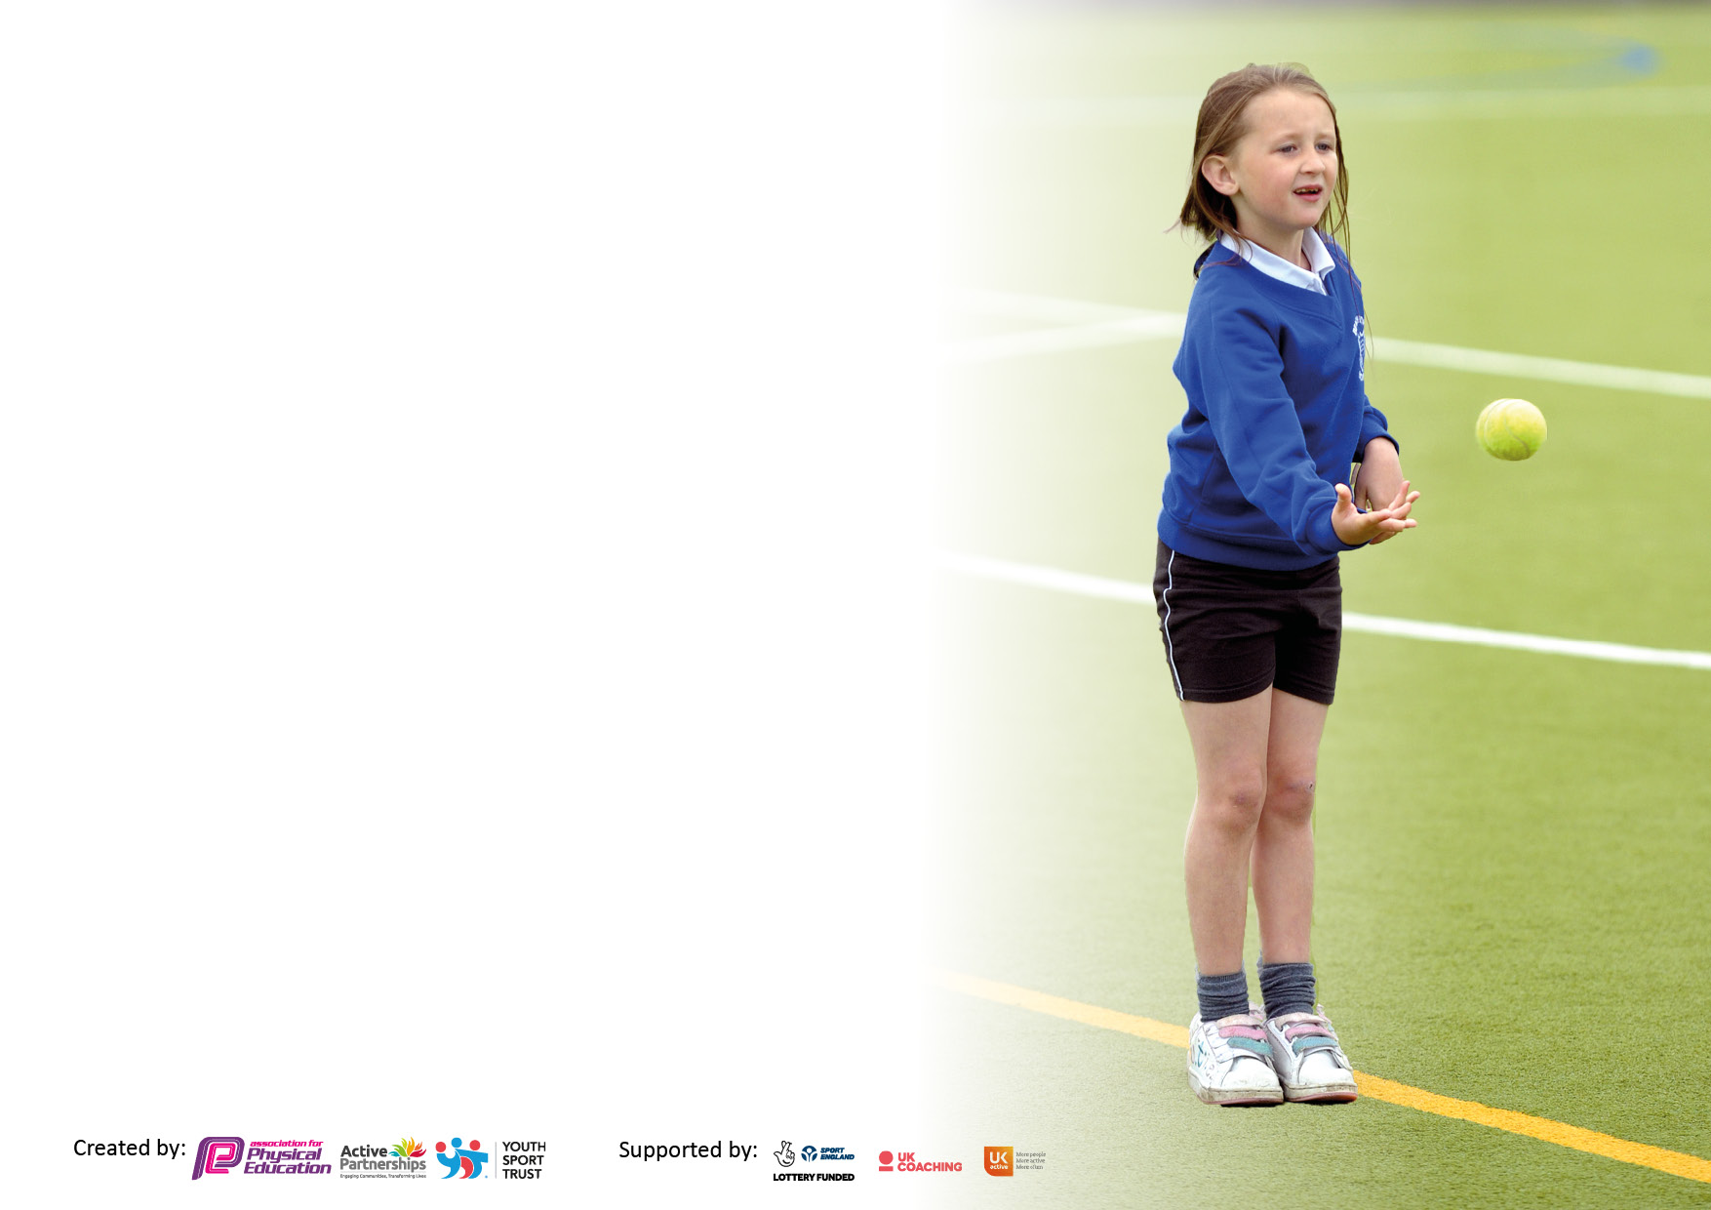

It is important that your grant is used effectively and based on school need. The Education Inspection Framework makes clear there will be a focus on ‘whether leaders and those responsible for governors all understand their respective roles and perform these in a way that enhances the effectiveness of the school’.

Under the Quality of Education Ofsted inspectors consider:
Intent - Curriculum design, coverage and appropriateness
Implementation - Curriculum delivery, Teaching (pedagogy) and Assessment
Impact - Attainment and progress

To assist schools with common transferable language this template has been developed to utilise the same three headings which should make your plans easily transferable between working documents.

Schools must use the funding to make additional and sustainable improvements to the quality of Physical Education, School Sport and Physical Activity (PESSPA) they offer. This means that you should use the Primary PE and sport premium to:

- Develop or add to the PESSPA activities that your school already offer
- Build capacity and capability within the school to ensure that improvements made now will benefit pupils joining the school in future years
- The Primary PE and sport premium should not be used to fund capital spend projects; the school’s budget should fund these.

Please visit gov.uk for the revised DfE guidance including the5keyindicatorsacrosswhichschoolsshoulddemonstrate an improvement. This document will helpyoutoreviewyourprovisionandtoreportyourspend.DfEencouragesschools to use this template as an effective way of meeting the reporting requirements of the Primary PE and Sport Premium.

We recommend you start by reflecting on the impact of current provision and reviewing the previous spend.

Schools are required to publish details of how they spend this funding, including any under-spend from 2021/2022, as well as on the impact it has on pupils’ PE and sport participation and attainment. The funding should be spent by 31st July but the DfE has stated that there will be no clawback of any unspent money so this can be carried forward into 2023/24.

We recommend regularly updating the table and publishing it on your website throughout the year. This evidences your ongoing self-evaluation of how you are using the funding to secure maximum, sustainable impact. Final copy must be posted on your website by the end of the academic year and no later than the 31st July 2023. To see an example of how to complete the table please click HERE.

Details with regard to funding
Please complete the table below.

Total amount carried over from 2020/21 | £4,905
Total amount allocated for 2021/22 | £24,495
How much (if any) do you intend to carry over from this total fund into 2022/23? | £432
Total amount allocated for 2022/23 | £19,500
Total amount of funding for 2022/23. Ideally should be spent and reported on by 31st July 2023. | £19,932
Swimming Data
Please report on your Swimming Data below.

Meeting national curriculum requirements for swimming and water safety.

N.B. Complete this section to your best ability. For example you might have practised safe self-rescue techniques on dry land which you can then transfer to the pool when school swimming restarts.
Due to exceptional circumstances priority should be given to ensuring that pupils can perform safe self rescue even if they do not fully meet the first two requirements of the NC programme of study
What percentage of your current Year 6 cohort swim competently, confidently and proficiently over a distance of at least 25 metres?  N.B. Even though your pupils may swim in another year please report on their attainment on leaving primary school at the end of the summer term 2023.  Please see note above | 90%
What percentage of your current Year 6 cohort use a range of strokes effectively [for example, front crawl, backstroke and breaststroke]?  Please see note above | 85%
What percentage of your current Year 6 cohort perform safe self-rescue in different water-based situations? | 75%
Schools can choose to use the Primary PE and sport premium to provide additional provision for swimming but this must be for activity over and above the national curriculum requirements. Have you used it in this way? | No

Action Plan and Budget Tracking
Capture your intended annual spend against the 5 key indicators. Clarify the success criteria and evidence of impact that you intend to measure to evaluate for pupils today and for the future.

Academic Year: 2022/23 | Total fund allocated: | Date Updated:
Key indicator 1: The engagement of all pupils in regular physical activity – Chief Medical Officers guidelines recommend that primary school pupils undertake at least 30 minutes of physical activity a day in school |  |  |  | Percentage of total allocation:
 |  |  |  | 9%
Intent | Implementation |  | Impact
Your school focus should be clear what you want the pupils to know and be able to do and about  what they need to learn and to  consolidate through practice: | Make sure your actions to achieve are linked to your intentions: | Funding allocated:  £1769 | Evidence of impact: what do pupils now know and what can they now do? What has changed?: | Sustainability and suggested next steps:
To continue the school’s commitment to all pupils being able to have active playtimes.  To ensure that there are a variety of clubs for the children to attend that involve physical activity. We are also focusing on engaging girls in sport.  To continue to ensure quality teaching. To have clear plans across the school which show a clear progression of skills.  To provide a classroom based physical activity that can be used as a short mental break or when the outside space cannot be used due to bad weather – ice or heavy rain. | Premier Sports will provide lunchtime clubs for both KS1 and KS2, three lunchtimes a week. KS1 will focus on multi-sports and KS will focus on a variety of sports including tag rugby and table tennis.  We are starting a new girls’ football club in the summer term. We are hoping this will encourage more girls to be physically active and be involved in the developing world of girls’ football.  The school has continued to use PE Hub plans this academic year. These plans have continued to ensure that teachers are teaching units of a variety of sports and physical activities. We have reviewed another PE Scheme as we had considered concerns about the amount of detail on the PE Hub plans. After the review, we have decided to continue with our current scheme.  Implementation of Jump Start Jonny which can be used in all classrooms. | £780  £350  £350  £289 | The children now have the opportunity to drop in to lunchtime sessions of various sports and physical activities. Not only does this add to the active nature of lunchtimes, but it provides an alternative area for children to head if they want to join in with activities led by an adult.  This has been a very popular addition to the clubs’ timetable. There is now a waiting list for children to join. It also seems to have promoted more girls to join the mixed football sessions on an alternative day. The main impact of this is that more girls are now participating in a team sport.  The impact of these plans is to ensure that progression is made across the curriculum. It also enables the teacher to access a range of activities that they can adapt to ensure that the lessons are appropriate for their classes and that the meet the Learning Challenge.  Two PE lessons a week are being consistently taught by all classes. Staff are confident at using the plans and are able to adapt the plans to suit the needs of their class. | To continue to monitor how well attended the lunchtime clubs are attended and what the benefits are for the children.  To continue to discuss with Premier Sports the availability of an extra coach to enable more girls to attend the club. To use the women’s world cup in the summer as a tool to helping to keep girls engaged in football and other team sports.  To use the curriculum planner more effectively to monitor the progression of the areas being taught.  Currently we are happy with the quality of the teaching plans, plus the use of JASC plans for certain lessons. This is an area we will continue to review.
Key indicator 2: The profile of PESSPA being raised across the school as a tool for whole school improvement |  |  |  | Percentage of total allocation:
 |  |  |  | 0.3%
Intent | Implementation |  | Impact
Your school focus should be clear what you want the pupils to know and be able to do and about  what they need to learn and to  consolidate through practice: | Make sure your actions to achieve are linked to your intentions: | Funding allocated:  £62.82 | Evidence of impact: what do pupils now know and what can they now do? What has changed?: | Sustainability and suggested next steps:
To raise the profile of School Sports- and competitive sports.  For the Sports Crew to run activities three lunchtimes a week which they have planned, organised and then carry out. This is an opportunity for Year 6 to have pupil voice and develop their leadership skills. To provide an additional structured exercise opportunity for children across KS1 and KS2.  To raise the profile of sport, physical activity and the Sports Crew.  To help the profile of Holy Trinity Sport and PE to be raised internally and externally.  Raising the profile of competitive sport  Using PE as an intervention tool | Children are presented with certificates during achievement worship and their participation and successes are recorded in the School newsletter.  Subject leader and Year 6 pupils attended the Sports Crew Training.  The specialist PE teacher (from JASC) met with the Sports Crew to help them to structure their activities.  The run lunchtime sessions 3 times a week.  To continue to update a Sport/PE board and Sports Crew Board Board – a celebration of all the sports that are taking place in the school, lessons, competitions, special visitor sessions, sports specialist sessions and Sports Crew sessions  Kit for adult – options currently being researched.  Staff hoodie – staff to purchase their own  Medals for children who won football tournament  Working with small groups of children who benefit from physical activity either to help regulate behaviour or improve motor skills. See below for more information. | £49.50  £13.32 | Children are more aware of all the competitions and festivals that the school is taking part in. We are continuing to ensure that as many children as possible have the opportunity to take part in these events.  This again has been a successful way to encourage a range of children to be active at playtimes.  Sports Crew also provides excellent leadership opportunities, including helping with external events run by our SSO. The Sports Crew particularly enjoyed helping with the KS 1 sports morning, enabling them to support the younger children and use their leadership skills.  The younger year groups are more aware of Sports Crew and what they provide. The Sports Crew spoke in a Worship and created posters to explain the activities that they are providing  The impact of these intervention groups has been varied and very helpful. Children who were struggling to interact with each other in a positive way, are now able to communicate more effectively and children who find it difficult to settle in the classroom were helped by being active straightaway. | We will continue to be members of Mid-Sussex Active.  We are hoping to host more netball and football friendlies at HT next year.  Consider starting this in earlier in the academic year by conducting our own training.  Two year groups have been identified as year groups that would benefit from extra support and intervention groups in Autumn 1.

Key indicator 3: Increased confidence, knowledge and skills of all staff in teaching PE and sport |  |  |  | Percentage of total allocation:
 |  |  |  | 56%
Intent | Implementation |  | Impact
Your school focus should be clear | Make sure your actions to | Funding | Evidence of impact: what do | Sustainability and suggested
what you want the pupils to know | achieve are linked to your | allocated: | pupils now know and what | next steps:
and be able to do and about | intentions: | £11,095.20 | can they now do? What has
what they need to learn and to |  |  | changed?:
consolidate through practice:
To ensure that teachers are confident teaching and assessing a range of Sports and Physical Activities. Our intent is to give teachers opportunities to see PE and Sports Specialist providing both ideas and techniques for teaching.  To implement a more organised sports day for both KS1 and KS2. To ensure that there is a clear competitive element in the KS2 event.  To attend courses looking at the best use of the Sport Premium money and courses such as inclusion for all children.  Courses attended:  - PE Co-ordinator Meeting - Wednesday 28th September - 9:15 - 15:00  - PE Co-ordinator CPD - Wednesday 19th October - 13:00 - 16:00  - Physical Literacy CPD - Tuesday 22nd November - 9:15 - 15:00  - 1st Steps Invasion and Net Games CPD - Wednesday 29th November - 9:15 - 15:00  To ensure implementation and sustainability of Sport Premium Funding, organisation of events/administration in relation to the School Games Mark, development of curriculum and assessment documents.  To continue to improve the teaching of gymnastics. | The school is employing a specialist PE teacher from JASC Sports.  The specialist teacher is modelling excellent teaching in areas that have been identified an area in need of training across the staff. This year a key area of focus was orienteering and gymnastics or dance.  The specialist teacher has helped train and run the Sports Crew enabling them to develop their leadership skills and to provide an opportunity for them to have pupil voice.  The specialist teacher has helped monitor the curriculum coverage and has made suggestions about how to track the progression and attainment of the children.  This year a big focus has been on working with small groups of children in nurture groups. We initially focused on children from year 3 to aid with the transition from infants to juniors. We have also focused on children in another year groups who are struggling with playing with each other in a kind manner.  The specialist teacher helped the PE Lead to organise and implement Sports Day for KS1 and KS2 and Area Sports.  Equipment needed:  The sports specialist runs a netball club.  Subject Leader time  Teachers had highlighted that the heaviness of the current gym mats makes it difficult to conduct a lesson on their own as the mats are too heavy children to move. New lightweight mats have been purchased. | £6,952.50  £66.97  Cost of supply  £1005  £3777.29  £597.67 | The confidence of teachers has grown hugely having had the specialist teacher demonstrating and team teaching with them. The enthusiasm for PE is higher and the two lessons of PE (indoor and outdoor) are being consistently taught across the school. The children are being taught to a higher standard, with clear learning challenge and success criteria and well-structured lessons.  The number of children that are now engaged in a physical activity during playtimes has increased. The year 6 sports crew members are running the sessions independently.  This year we took over 70 children to participate in Area Sports meaning that many children were able to have the experience of a big sporting event.  The impact of these intervention/nurture groups has been varied and very helpful. Children who were struggling to interact with each other in a positive way, are now able to communicate more effectively and children who find it difficult to settle in the classroom were helped by being active straightaway.  Continuing to ensure that the Sport Premium money is being spent effectively and sustainably. Provision of opportunities for all children to attend events. Creation of a curriculum that shows progression and identifies areas that need development for both children and teachers.  From the Autumn term teachers will feel happier to ask their classes to help move the mats as they will be lighter for the children to handle. | Next year JASC will be working at HT on two days. This means that we will be able to continue to provide support in terms of teaching, assessment and PE as a whole school improvement tool.  We are looking at ways to amend the assessment document to highlight children who are exceeding expectations. We can then help them to find local pathways into sports, if that is something that they would like to pursue.  A focus next year during CPD lessons will be on how to set up PE lesson effectively and what you need to look for when assessing children in PE.  We will continue to attend courses and use staff meeting time for training. This is to provide new ideas and to help teachers to feel increasingly confident about teaching a range of PE and sport.
Key indicator 4: Broader experience of a range of sports and activities offered to all pupils |  |  |  | Percentage of total allocation:
 |  |  |  | 20.5%
Intent | Implementation |  | Impact
Your school focus should be clear | Make sure your actions to | Funding | Evidence of impact: what do | Sustainability and suggested
what you want the pupils to know | achieve are linked to your | allocated: | pupils now know and what | next steps:
and be able to do and about | intentions: |  | can they now do? What has
what they need to learn and to |  | £4080 | changed?:
consolidate through practice:
To encourage children to take part in a variety of sports to increase the enjoyment and participation of physical activities.  JOLF has been identified as a provider that works very well in KS1 as it helps to develop basic coordination and teamwork skills.  To provide an outdoor opportunity which promotes being active and helps with the children’s wellbeing.  Cycling proficiency | JOLF Playdays  KS1 Autumn Term and Reception will work with JOLF each week for 6 weeks.  Nurture groups to be run by JOLF across the whole school.  Each year group goes to Forest School one morning or afternoon per term | £3080  £1000 | KS1 worked with JOLF at various points through the year. This enables the children to practise following instructions for a carousel of activities, using their hand-eye-ball co-ordination and working as part of a team.  This continues to be a huge success, particularly for children who perhaps find the norms of learning in the classroom a challenge.  To encourage as many children as possible to take part in the bikeabilty scheme. | We are going to review whether we will use this provider next year.  Another member of staff has been trained in Forest School.

Key indicator 5: Increased participation in competitive sport |  |  |  | Percentage of total allocation:
 |  |  |  | 6%
Intent | Implementation |  | Impact
Your school focus should be clear | Make sure your actions to | Funding | Evidence of impact: what do | Sustainability and suggested
what you want the pupils to know | achieve are linked to your | allocated: | pupils now know and what | next steps:
and be able to do and about | intentions: |  | can they now do? What has
what they need to learn and to |  | £1150 | changed?:
consolidate through practice:
To continue to increase pupil participation in, and enjoyment of, competitive activities.  To continue to develop a variety of children’s ability to  lead and organise sporting activities  Support for subject leader and in turn the subject leader is able to  confidently support and guide teaching staff.  For as many children across year groups and abilities to attend festivals and tournaments.  To engage and host in more competitive football matches | MSA Partnership - continued membership with Mid Sussex Active.  Mid Sussex Active provide:  extensive quality assured professional development programme for teaching staff  access to a wide range of inter- school competitions and festivals for children from R – Yr6  training to develop young people as sports leaders,  specialist advice and support from our local secondary schools,  support, training and networking opportunities for PE co-ordinator and other members of staff.  see www.midsussexactive.org.uk for further information and reports about events/training/calendar etc  Purchase and fit new sturdy football posts that are more suitable for longer term use and for matches. | £7000 (until 2025) Paid in previous year  Coach costs  £600  Posts £550 | This will be evidenced through the data gathered of how many children attended MSA or cluster events.  Over the time that events were running (September 2022-July 2023) the following percentages of children took part in events:  Year 3 – 43%  Year 4 – 56%  Year 5 – 65%  Year 6 – 68%  12 children in Year 6 were involved in Sports Crew and the leadership opportunities that this provides.  See above for the evidence in relation to the impact of the Sports Crew and the involvement of School Council.  Support received from Active Sussex in terms of Sports Premium documentation.  See above re information about Area Sports.  From Autumn 1 in September 2023, we are hoping to be able to host more football matches.

Signed off by
Head Teacher: | Ann MacGregor
Date: | 21st July 2023
Subject Leader: | Zoe Macwhinnie
Date: | 19th July 2023
Governor: | Fiona Halsey
Date: | 21st July 2023

