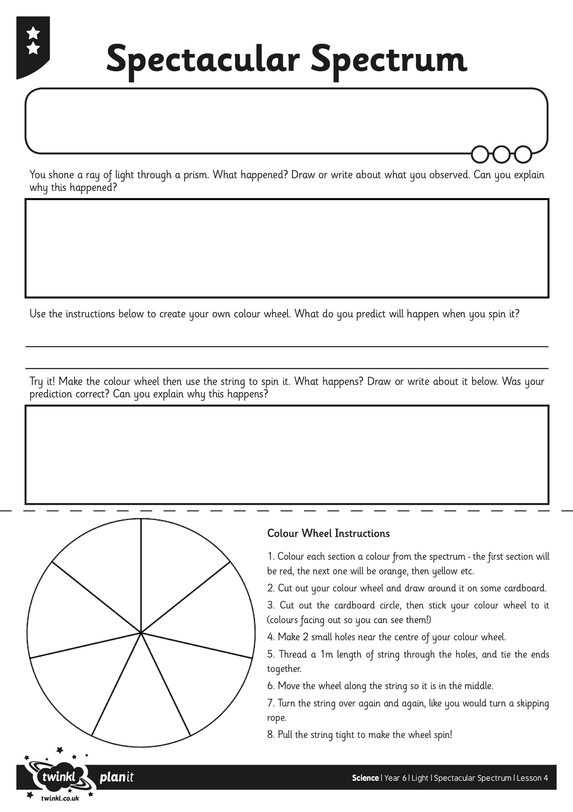

We will look at this when we’re back at school..

I can understand how a prism affects a ray of light.

I can explain what this tells us about the visible spectrum.

I can make my own colour wheel and explain what it shows about light.