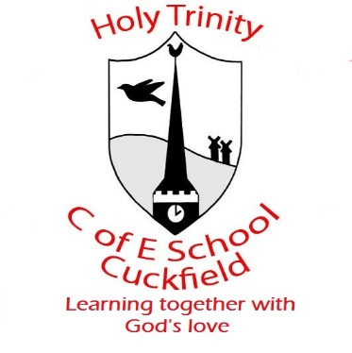
Instrumental Lessons

Spring Term 2021
Music lessons will commence the week beginning 17th January 2022.

Instrumental Teacher | Instrumental Lesson | Day and Time | Contact
Rhiannon Harman  STARTING ON 10th January | Piano, Voice and Flute  Year 3,4,5,6 | MONDAY  11:15-2:45 pm | rhiannon@discoverandbe.com  Tel: 07472 521161
Clare Harms  (Music Room) | Piano and Keyboard  Yr R - Yr 6 | TUESDAY  09:30 am -1:00 pm | clareharmsart@gmail.com  07967 038758
Rodney Smith | Flute and Recorder  Year 3,4,5,6 | TUESDAY  1:00-3:15 pm | musicrodneysmith@gmail.com  07714 894161
Jane Haughton  (Piano Room)  STARTING ON 11th January | Piano | TUESDAY – 9:00-3:15 pm | janehaughton27@gmail.com
Clare Harms | Piano and Keyboard  Yr R - Yr 6 | WEDNESDAY  09:20-2:30 pm | clareharmsart@gmail.com  07967 038758
Clare Harms  (Piano Room) | Piano and Keyboard  Yr R - Yr 6 | THURSDAY  11:30 am -2:50 pm | clareharmsart@gmail.com  07967 038758
Fergus Paton | Guitar  Yr 3-6 | THURSDAY  09:00 am – 1:00 pm | fergus.paton@westsussexmusic.co.uk  07761 480100
Miriam Turner | Violin | THURSDAY  1:00 pm - 3:15 pm | miriam.Turner@westsussexmusic.co.uk
Clare Harms  (Piano Room) | Piano and Keyboard  Yr R - Yr 6 | THURSDAY  09:30-2:50 pm | clareharmsart@gmail.com  07967 038758

