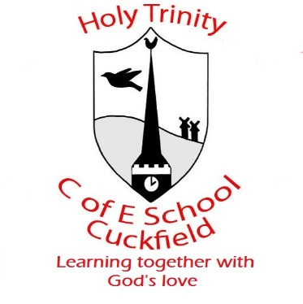
Instrumental Lessons

Autumn Term 2021
Instrumental Teacher | Instrumental Lesson | Day and Time | Contact
Rhiannon Harman | Piano, Voice and Flute  Year 3,4,5,6 | MONDAY  11:15-2:45 pm | rhiannon@discoverandbe.com  Tel: 07472 521161
Rodney Smith | Flute and Recorder  Year 3,4,5,6 | TUESDAY  1:00-3:15 pm | musicrodneysmith@gmail.com  07714 894161
Clare Harms | Piano and Keyboard  Yr R - Yr 6 | WEDNESDAY  09:00-2:20 pm | clareharmsart@gmail.com  07967 038758
Clare Harms  (Piano Room) | Piano and Keyboard  Yr R - Yr 6 | THURSDAY  09:00 am – 1:00 pm | clareharmsart@gmail.com  07967 038758
Fergus Paton | Guitar  Yr 3-6 | THURSDAY  09:00 am – 1:00 pm | fergus.paton@westsussexmusic.co.uk  07761 480100
Miriam Turner | Violin | THURSDAY  1:15 - 3:15 pm | miriam.Turner@westsussexmusic.co.uk
Clare Harms | Piano and Keyboard  Yr R - Yr 6 | FRIDAY  09:00-2:20 pm | clareharmsart@gmail.com  07967 038758
Jane Haughton | Piano | TUESDAY – 9:00-3:15 pm | janehaughton27@gmail.com

