**Can you make a spiders web ?**

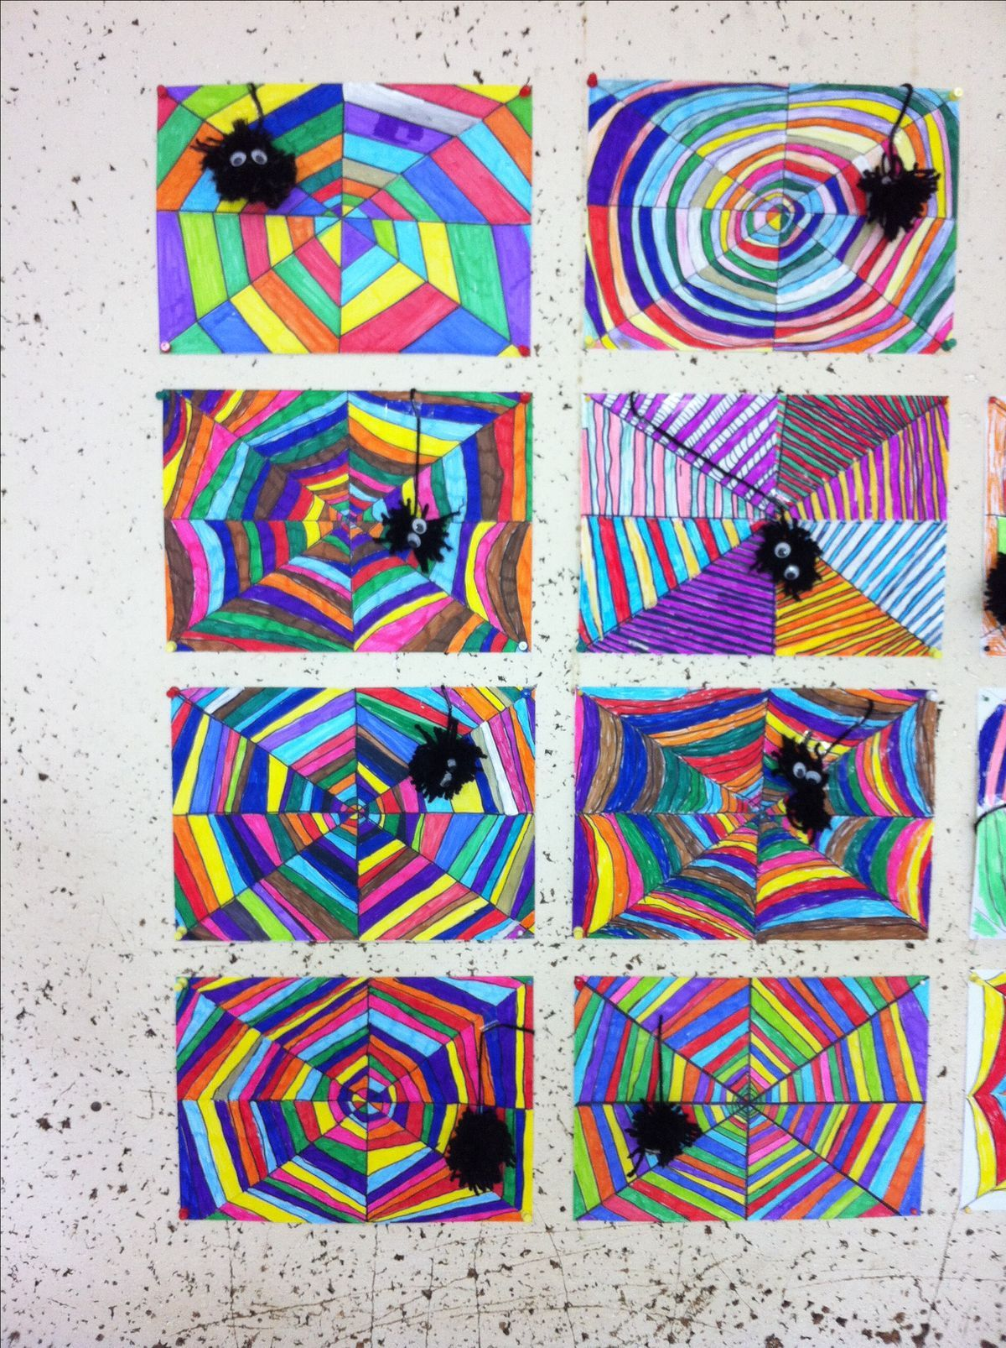

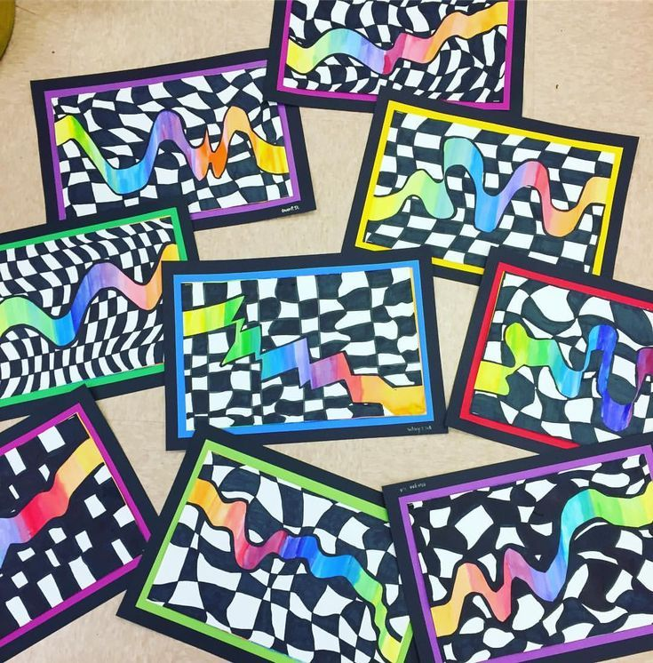

**Can you make a rainbow wiggle?**

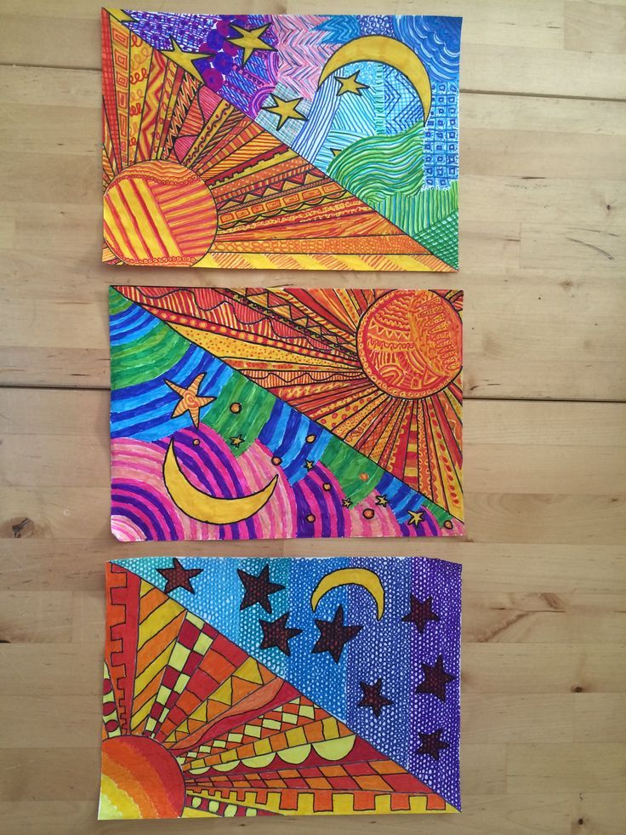

**Can you make a night and day picture ?**