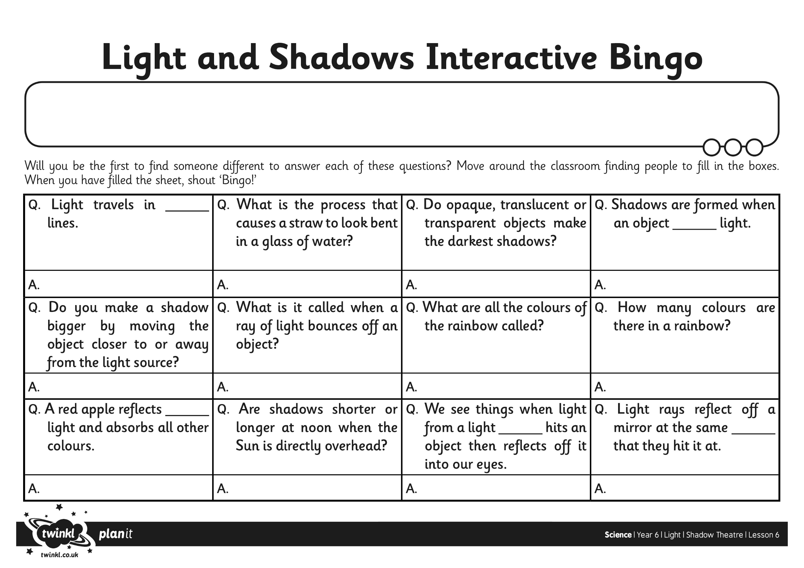

I can explain how a shadow is formed.

I can explain why shadows are the same shape as the object that casts them.