E4S KS1 Being Safe - Worries and asking for help

Cornerstone: | RSE
Concept: | Being Safe
Theme: | Worries and asking for help
Key Questions: | Teachers have used the questions and statements from the E4S curriculum to plan lessons on being safe, which are delivered throughout the year according to the school’s scheme of work.  This is what your child will be learning about in the upcoming scheme of work:  - How does it feel in our bodies when someone makes us feel safe?  - How do our bodies react when we don’t want to be touched?  - Who should we tell if we feel uncomfortable, worried or confused  - Who looks after us?  - Who helps us to keep safe?  - Who and what can help us when we feel worried or unsafe?  - Who helps me?  - How do we know whom to ask for help?
Questions to consider with your child: | When do you feel safe?  Where do you feel safe?  What makes you feel safe?  Who keeps you safe?  Who are your trusted adults?  Who can you talk to if you feel worried or uncomfortable about something?
Suggested Resources for parents: | Please find additional support and guidance below in relation to worries and asking for help.  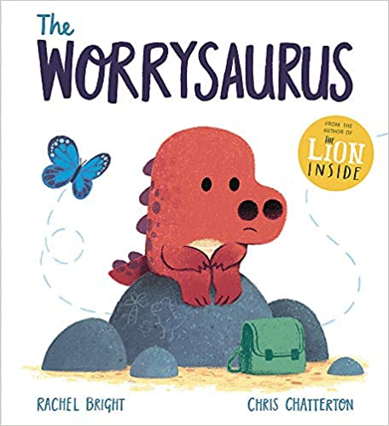  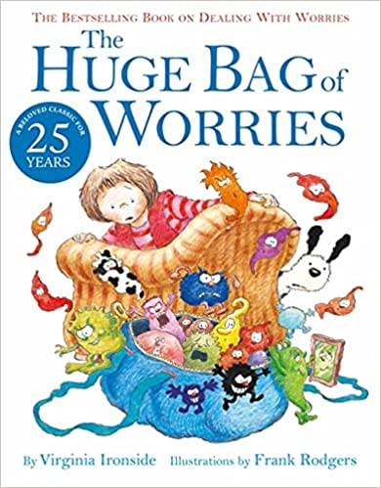  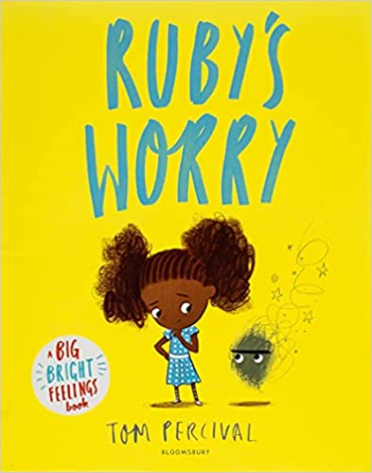  Ruby's Worry  The Huge Bag of Worries  The Worrysaurus  NHS  Young Minds

