I can add voice sounds to enhance an animated story.

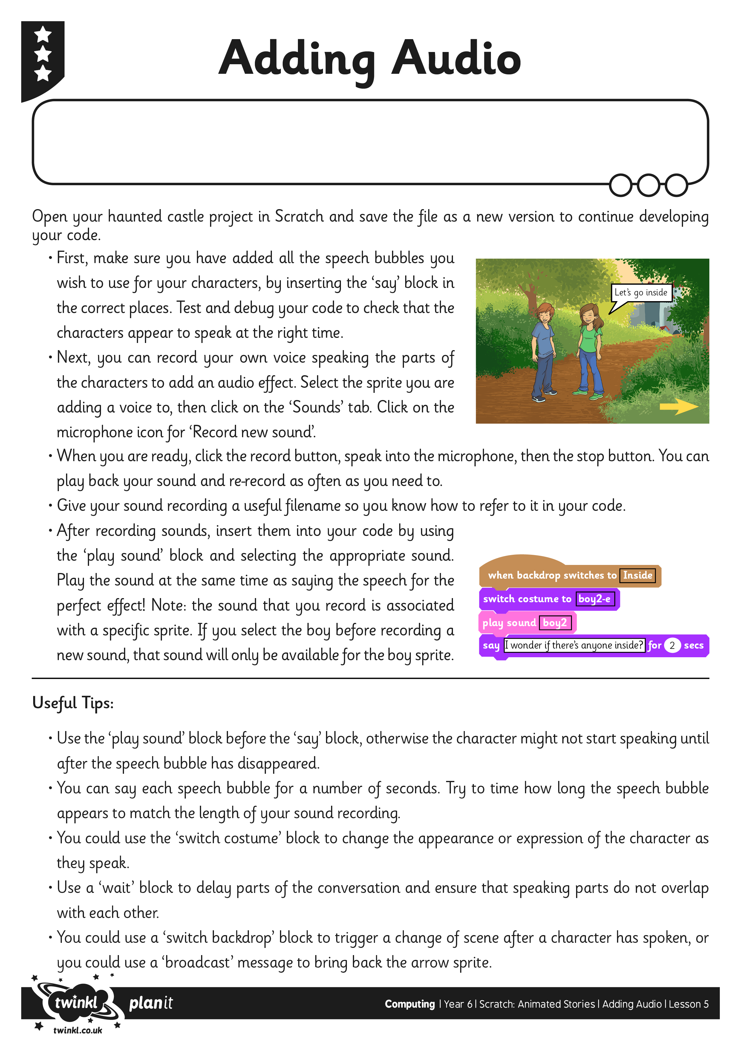

I can add voice sounds to enhance an animated story.