
Enter Contact Information Here | 1127 Lombard Blvd. San Francisco, CA 59802 | phone 555.555.5555 | fax 555.555.5555
Enter Contact Information Here | 1127 Lombard Blvd. San Francisco, CA 59802 | phone 555.555.5555 | fax 555.555.5555
Learning Support Assistant Term Time only from October 2023
Fixed Term 1 year Contract with the possibility of extension

8.45am – 3.15 pm (5 days per week) ½ hour lunch break
MMS - 12.00pm – 1.00 pm (5 hours per week )

• POSITION SUBJECT TO HEALTH CHECK, REFERENCES AND COMPLETION OF SATISFACTORY PROBATIONARY PERIOD
• POSITION SUBJECT TO CRIMINAL RECORDS CHECK (CRB/DBS)

www.holytrinity-cuckfield.w-sussex.sch.uk

wE ARE LOOKING FOR A RELIABLE, MOTIVATED AND ENTHUSIASTIC Learning support ASSISTANT TO JOIN OUR FRIENDLY STAFF TEAM
This is an exciting opportunity for a current or aspiring Learning Support Assistant to work with pupils with a hearing impairment at Holy Trinity CE Primary School. Knowledge of British Sign Language / Makaton would be beneficial. The successful applicant will support the speech & language, learning and progress of groups of pupils in EYFS, Key Stage 1 & 2.

Please access Application FORM AND DETAILS VIA THE SCHOOL OFFICE OR WEBSITE
Applications to be submitted to Mrs. A. MacGregor (Headteacher) by Wednesday 11th October 2023. Interview date: Monday 16th October (interview, observation – working with a small group, paper task)
Rates of Pay LSA: LSA annual actual gross salary prorata term time and pro rata hours (17.5 hours per week) would be a range from £8291 to £8416. (actual salary grade 3.3 to 3.4)- Midday Meals salary is Grade 2.2 to 2.3 (5 hours per week) £2326 to £2363
Training and induction will be provided for the successful candidate. Previous experience is desirable but not essential.

Position vacant –
Learning Support (LSA)
Holy trinity Ce (A) Primary School
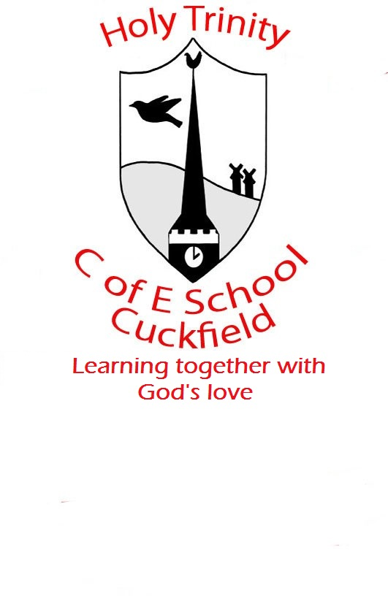

Delete text and place photo here.

Holy Trinity CE (A) Primary School, Glebe Road, Cuckfield, RH17 5BE; Phone: 01444 454295
Email: office@holytrinity.co.uk

