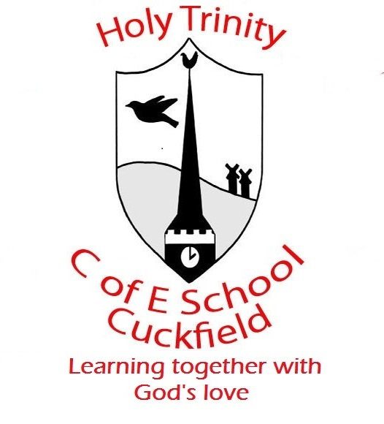 Update from Year 2 Week 4

Dear Parents / Carers Date: 31.1.20
This week in maths we have begun our statistics topic. The children have looked at tally charts and pictograms whilst also creating some of their own. They are really enjoying the visual element and we will be moving onto looking at block graphs next week. The Secret Agent Training in maths has gone very well! The children are very excited at the prospect of getting banana and chocolate in the morning, so a big thanks to those who have supported us with this.
In English we have been looking at the middle part of our traditional tales and we were all very pleased to finally read the story all the way through! They have developed their understanding of conflict and resolution and next week we will be finishing our stories by looking at different story endings. They are very enthusiastic to write up their own versions of Rapunzel in the following week.
In science we are exploring the topic of materials and everyday uses. In science this week the children completed an investigation on tights to find out which material was the stretchiest. Next week, they will be starting a small art and D.T project to create a blanket using sewing for Rapunzel.
In Elder we have welcomed Miss MaCloed, who will be starting to teach a few lessons in the course of the next week. We are also welcoming Mrs Rap who will be teaching in Hawthorn. Both are very excited and enthusiastic to start!
Please do continue to log onto MyMaths and TimesTablesRockstars. I am aware there was a small problem with a few children’s TTR but I’m hoping this has been resolved. Also, please continue to write in the Monkey Diaries, even if it is the pages they read or a signature because it helps us build a picture of the children who are reading every day – thank you for your ongoing support.
Another reminder that we are going on our Lewes Castle trip on the 7th of Feb, thank you to those of you who have signed up to come with us.
As ever, if you have any concerns or questions please do ask ☺

