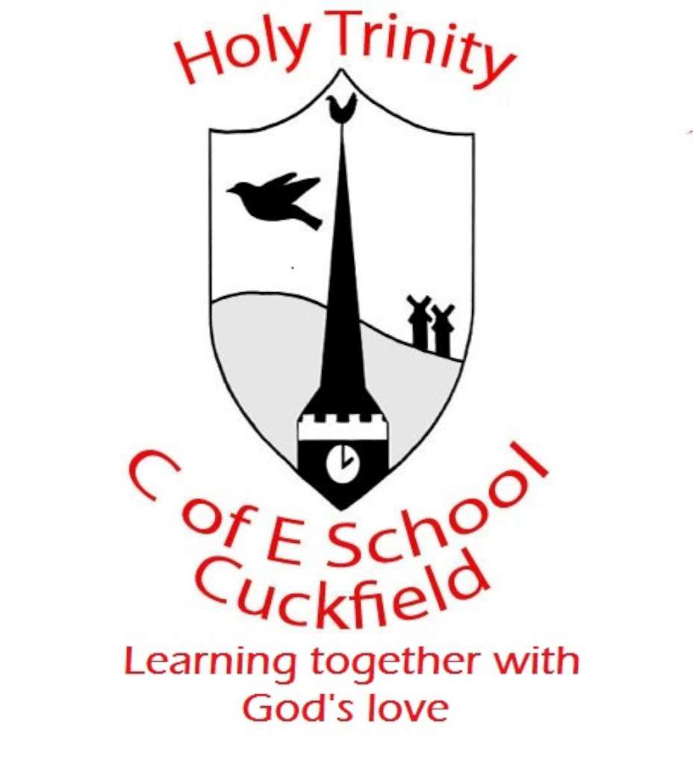

NOR: 419

Part Time Teacher
Required for September 2023

Are you a creative, dynamic and enthusiastic teacher?
If so, Holy Trinity CE (A) Primary School needs you!

We are a happy, lively and caring school and we can promise you children who are motivated, enthusiastic, well behaved and fun to be with. We put a strong emphasis on teamwork and individual professional development. We are committed to ensuring new team members are welcomed and fully integrated into our school. Applications from ECTs are welcome.

We are looking for an outstanding classroom practitioner who:

- Would be confident to work in year groups across Key Stage 2
- Has good organisational skills
- Is energetic, enthusiastic and creative
- Has a belief in children learning from direct experience of their immediate environment
- Puts a strong emphasis on an enquiry approach
- Has good team player credentials
- Has effective communication skills
- Holds a belief in a close partnership between home and school
- Shows a willingness to uphold the ethos of an Aided Church of England School
- Is resilient and flexible in their approach

In return we can promise:

- Encouragement and support to develop professional skills
- Support and co-operation from friendly and enthusiastic staff, governors, parents and children
- Opportunities to develop your career
- A supportive working environment

We are committed to safeguarding and all applicants must be willing to undergo screening including checks with past employers and the Disclosure Barring Service.

We would encourage you to visit the school. For further details and an application form, please contact our Office Manager Miss Sarah Raciti.

Part of the recruitment process will involve an observation in school by two members of the Senior Leadership Team at Holy Trinity CE (A) Primary School.

Closing date for applications is 12.00pm on Wednesday 24th May 2023



