Here is some extra work for you to try:
- Landscape description
Write a description of a landscape, watch this video to help you.
https://www.bbc.co.uk/bitesize/clips/z2vpyrd
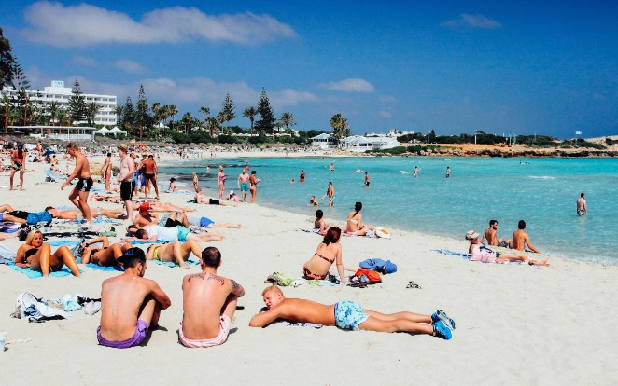
You could write a description of a coastal scenery, or have you got a photograph of a scene where you have been? Perhaps a beach, woodland or a castle. Try to write at least half a page. Think of all the punctuation you need to remember? What type of vocabulary will you use? Use the sheets to help you.
